1916 Easter Rising

At the time, Ireland was ruled by Britain but many people in Ireland wanted independence. In 1915 some groups of men including Patrick Pearse and James Connolly decided to rebel against the British.

They planned uprisings all over the country.

On Easter Monday, April 24, a group of about 1,800 people, including some women, took over buildings in Dublin. The General Post Office (GPO) became their headquarters. On the steps of the GPO, Patrick Pearse read aloud a statement. He declared that Ireland was a free country.

The British used heavy guns (artillery) against the Irish all over Dublin. Within a week, the leaders of the rising realized they would not be able to beat the army. They surrendered and were arrested by the British.

This is Sackville Street after the 1916 Rising.

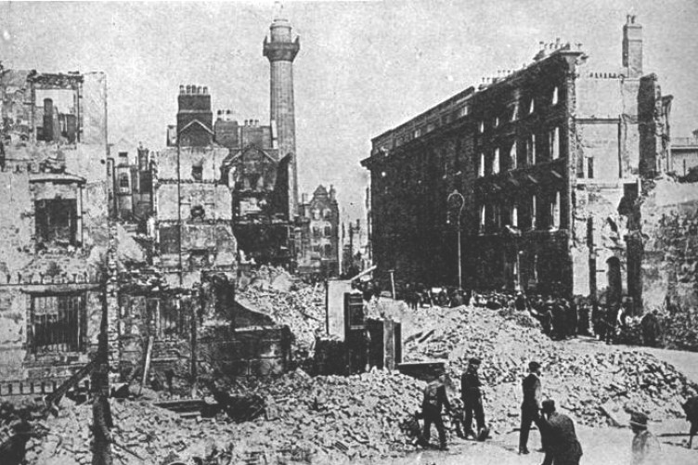

The trials of the leaders of the Easter Rising were held in secret. Pearse and 14 other leaders were sentenced to death. More than 500 people had died in the rising, including many ordinary citizens.

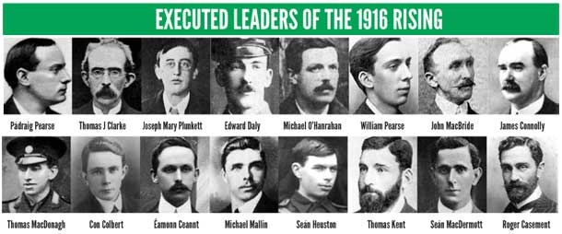

At first, the Easter Rising had little support in Ireland. After its leaders were executed, though, people began to respect what they had tried to do. The rising came to be admired, and its leaders became heroes. Eamon de Valera was one of those leaders. He survived the uprising and later became a leader of Ireland after it finally achieved independence.

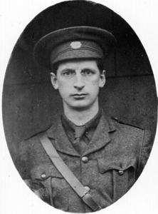

The Proclamation of the Irish Republic was issued at the start of the Rising
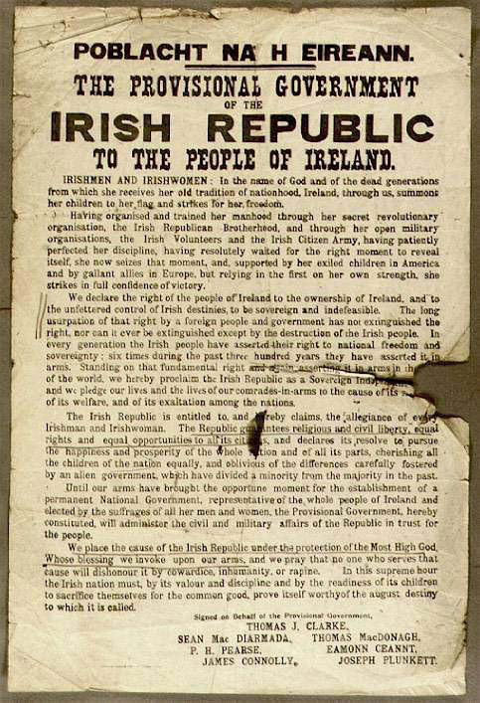

The Easter Rising lasted for 6 days
Around 500 people were killed and 2500 wounded during the Easter Rising

By Steven Reid 06th March 2016

