The Mona Lisa
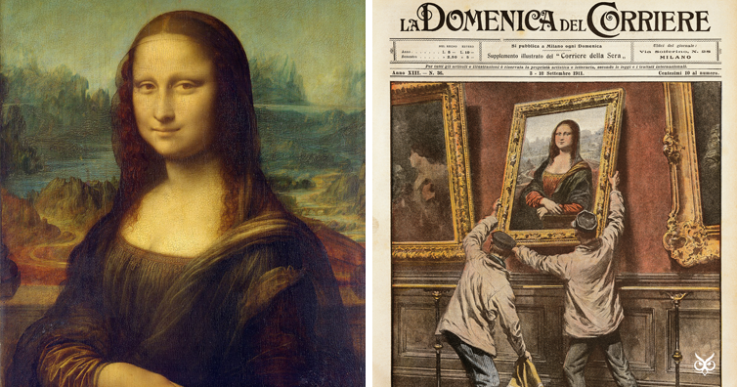
The Mona Lisa is a famous painting, by the amazing Leonardo di ser Piero da Vinci. The masterpiece was painted in 1503. The medium he used to make this painting was oil paints. The Mona Lisa started off as just a normal Renaissance painting, until the French Emperor, Napoleon Bonaparte, took a liking to it and hung it up in his bedroom. After that it became very popular and it was soon hung up in the Grand Gallery in the Louvre in 1804, but it wasn’t her first time being hung in a museum because in the 1530’s ( a few years after da Vinci’s death ) Francois I ( one of the French king’s ) hung her in a semi-public art gallery at Fontanainebleau, his favourite chateau. 77 years after she was installed in the Louvre, Vincenzo Perugia was born. When Vincenzo was older he decided to work in the Louvre as a carpenter. But on the 21rst of August, 1911, Vincenzo stole the Mona Lisa from the Louvre, loads of people were interrogated, including Picasso. But in 1913 Vincenzo was caught writing to an art dealer in Florence that goes by the name of Alfredo Geri offering 500,000 lire ( the Italian currency of that time period ) for it. He was then sent to jail. The Mona Lisa has been damaged a few times, in the same year a vandal threw acid over it and a man through a rock at it. Mona Lisa is still a very popular painting and one of the most viewed paintings ever.

