Fair Trade
Fair Trade is a social movement whose stated goal is to help producers in developing countries achieve better trading conditions and to promote.
Members of the movement advocate the payment of higher prices to exporters, as well as improved social and environmental standards. The movement focuses in particular on commodities, or products which are typically exported from developing countries to developed countries, but also consumed in domestic markets and most notably handicrafts,coffee, cocoa, sugar, tea, bananas, honey, cotton, wine, fresh fruit ,chocolate, flowers, gold, and 3D printer filament.
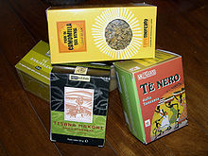
Fair Trade Tea

It promotes sustainable development by offering better trading conditions to, and securing the rights of, marginalized.
Producers and workers in developing countries. Fair Trade is grounded in three core beliefs; first, producers have the power to express unity with consumers. Secondly, the world trade practices that currently exist promote the unequal distribution of wealth between nations. Lastly, buying products from producers in developing countries at a fair price is a more efficient way of promoting sustainable development than traditional charity and aid.

