1916 Project by
Joe Condon
Jacob’s Biscuit Factory
Jacob’s factory had two towers. During the Rising those two towers were used for shooting out of. It was also very good for covering yourself because there was very little open space. The factory was on Bishop Street. The factory was originally in Waterford but got moved to Bishop Street in Dublin. It was founded in 1851. Its founders were William Beale and his brother Robert Beale.
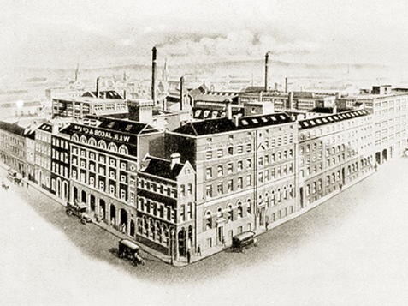
My Great Grandad John Cahill worked in Jacobs during the Rising where he worked as a baker.
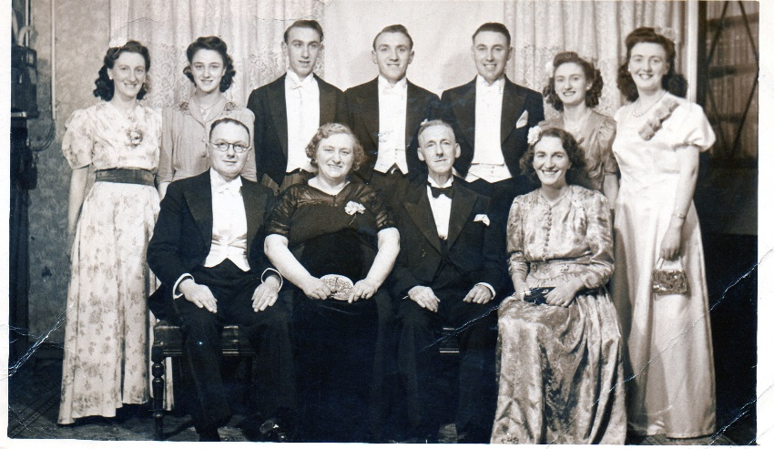
Great Grandad
John Cahill

Padraig Pearse
Padraig Pearse was born on Great Brunswick Street in 1879 (Which is now Pearse Street). He was an Irish teacher, poet and a barrister. He is one of only seven of the people who signed the Proclamation. He got executed at Kilmainham Gaol in Dublin. He was executed on the 3rd of May 1916. Pearse became very involved in The Gaelic Revival and he joined the Gaelic League at the age of sixteen. When Pearse turned twenty three he became the editor of the newspaper An Claidheamh Soluis (The Sword of Light).
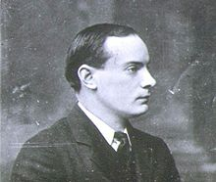

He was always seen facing sideways in pictures like you can see here.

Proclamation
Approximately 1,000 copies of the Irish Proclamation were printed. All of the copies were printed in the basement of Liberty Hall. On Monday the 24th of April Padraig Pearse read out the proclamation outside the G.P.O. It was printed on a machine called a Wharfedale. Everyone that signed the Proclamation got executed by British soldiers. On the 19th line down there is a problem with all of the E letters.
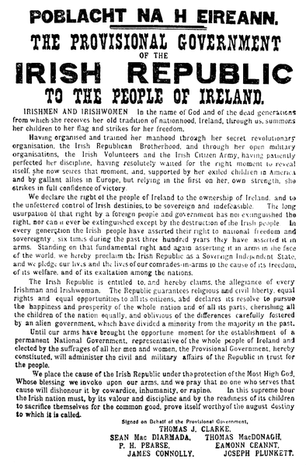

James Connolly

James Connolly was born on the 5th June 1868 and died on the 12th of May 1916. He joined the Army when he was only 14 and he was in the Army for nearly 7 years. He was born in Edinburgh, Scotland. Connolly only had a small education as he left school at the age of ten. He was in a school called St Patrick's Roman Catholic parish.
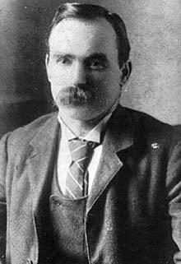

The G.P.O
The G.P.O was probably the main building during The 1916 Rising. The G.P.O is in the heart of Dublin. It was on Sackville Street (O’Connell Street today). It is one of Ireland's most famous buildings. On Easter Monday armed groups of the Irish Volunteers and the Citizen Army, commanded by Padraig Pearse and James Connolly, took over the G.P.O where they proclaimed the Irish Republic.
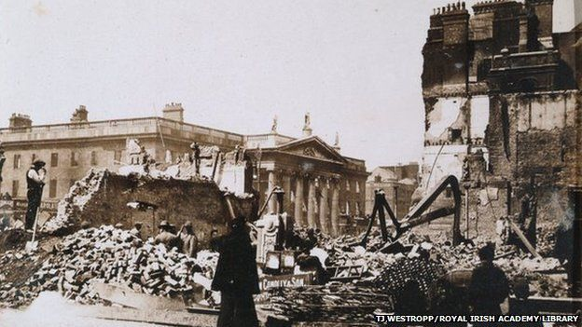
Here is what the G.P.O looked like during 1916.
Here is what the G.P.O looks like now.

The O’Rahilly
Michael Joseph O’Rahilly was born on 22nd of April 1875 and died on the 29th April 1916. He died four days after his birthday. He led a group in a charge up Moore Street and got as far as the corner of Ridley Road and Moore Lane when he was shot. Two of the O’Rahilly’s most famous quotes were – Well I’ve helped to wind up the clock and the other one was – I might as well hear it strike. He didn’t want the Rising to go ahead. Despite his actions to stop the Rising he couldn’t do anything. He was one of the founders of the Irish Volunteers. He crawled over to a building, took out a piece of paper to write a note to his wife. He wrote on the note after he was shot in his foot that it was good fight anyhow.
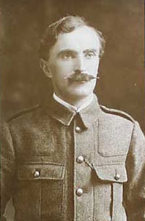

Kilmainham Gaol

When Kilmainham Gaol was built in 1796 it wasn’t called Kilmainham Gaol, it was called New Gaol. All of the leaders alive at the end of the war got executed. Those leaders were Padraig Pearse, Thomas Clarke, Thomas McDonagh, Joseph Plunkett, Edward Daly, Michael O’Hanrahan, Willie Pearse, John MacBride and others. The most people that got executed in a day was four.
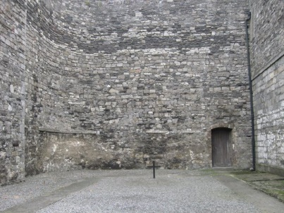
Here is the execution yard where the men and women got shot.

My Great Great Grandmother Christina Dunne

My Great Great Grandmother was a member of Cumann na mBan. She was well known in the IRA for her activities during The War of Independence. She worked alongside Maud Gonne McBride who founded the Prisoners Defence League to ensure the rights of the Republican Prisoners held by the Free State Government. She was President of the Visiting Committee to the prisons.
She lived with my Great Great Grandad Arthur and she was able to hide a lot of ammunition in her home without much trouble from the British Army. She wasn’t considered a threat because her husband was an English man who had a strong British accent. Floral tributes were placed on her grave from the Prisoners Defence League and Maud Gonne McBride.
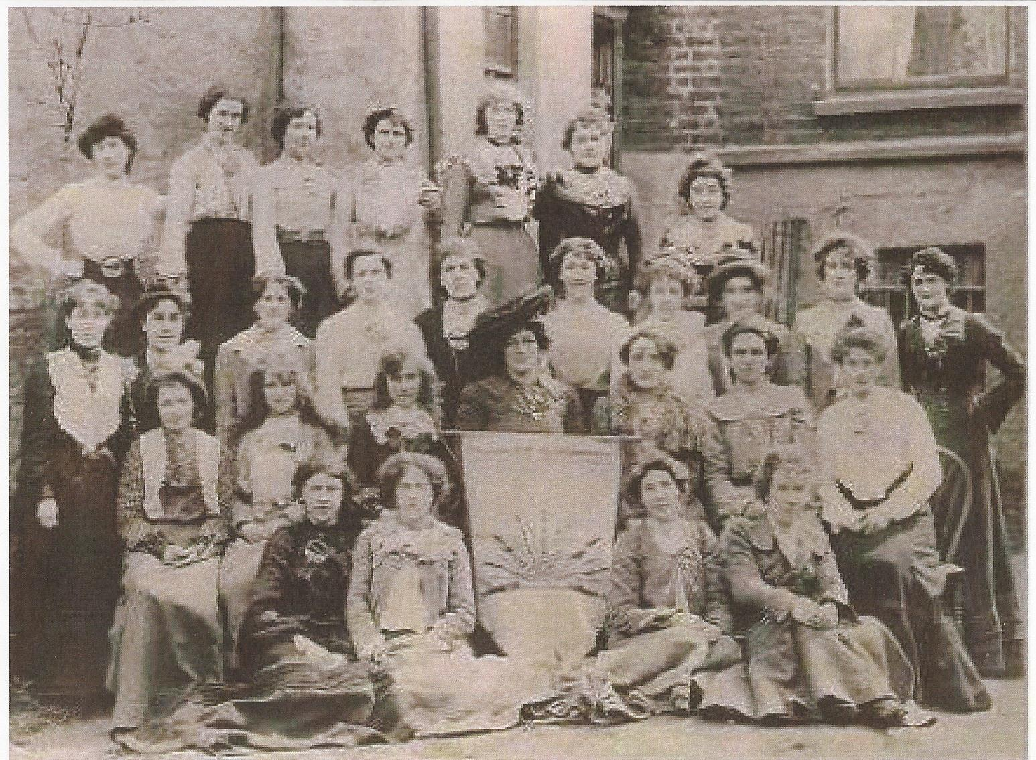
Maud Gonne McBride and sitting on her right hand side is my Great Great Grandmother Christina Dunne

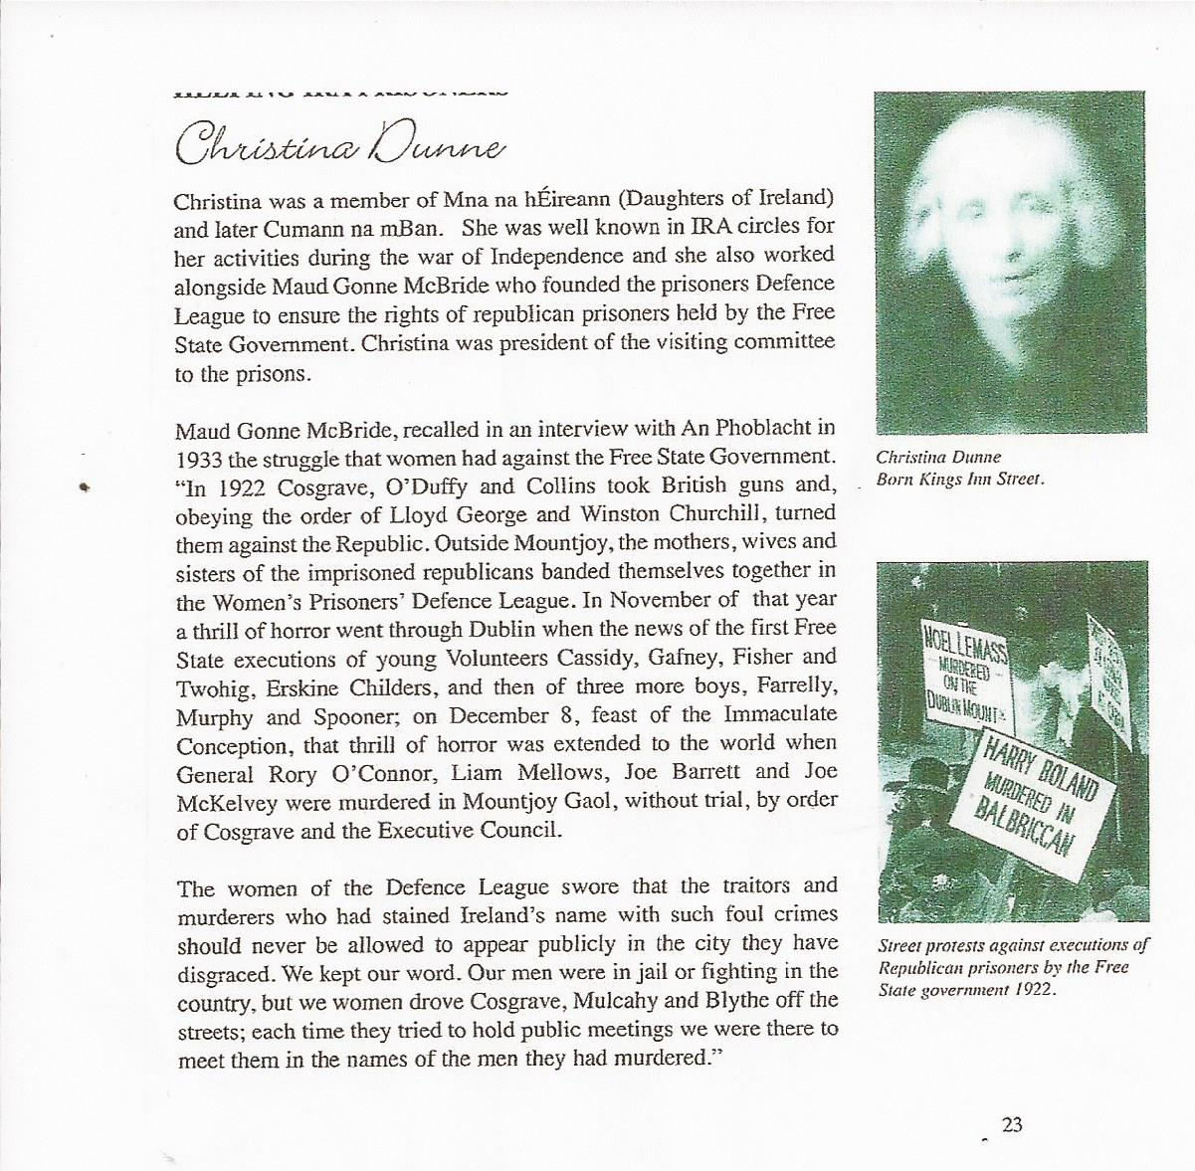
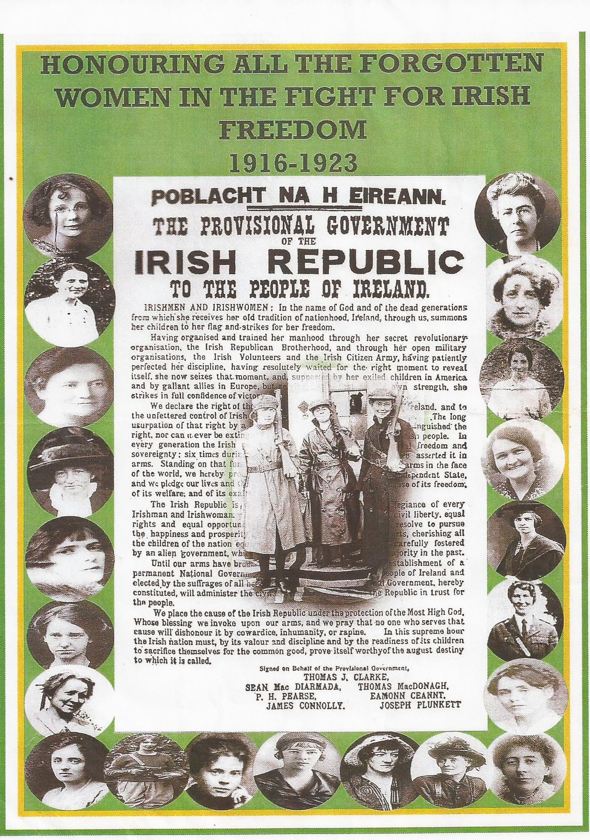
My Great Great Grandmother
Christina Dunne

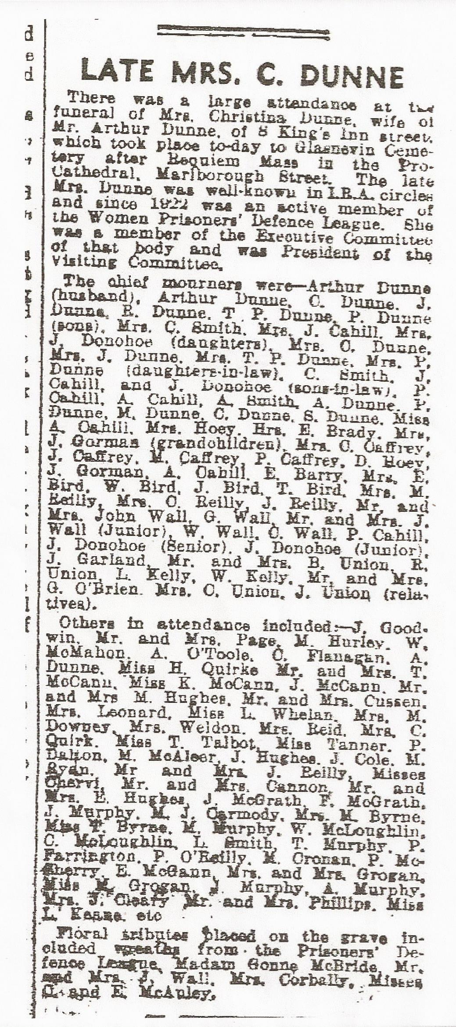
The Death Notice in the newspaper of my Great Great Grandmother Christina Dunne and it says on the end that flowers were left by the Prisoners Defence League and Maud Gonne McBride

