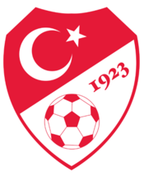 |  | 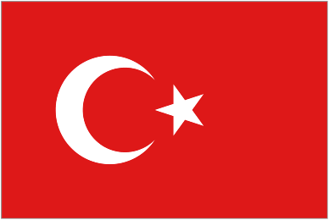
Turkey
National Soccer Team

The Turkish national soccer team played their FIRST EVER MATCH against Romania in 1923 nearly 93 YEARS AGO and they drew 2-2.

They are currently ranked number 18th in the world just ahead of Ukraine. During the Euros in 1996 they beat Switzerland and Sweden 2-1. They didn’t score anymore after that and then they got knocked out! At least they went home with one award “The Fair Play Award” and it was given to Alpay Ozalan.
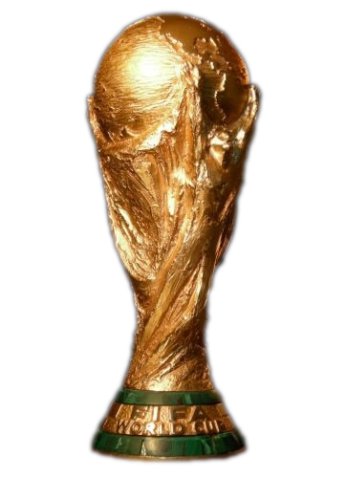 World Cup 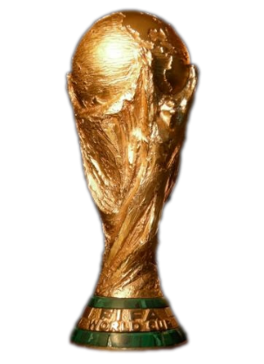
History

Turkey have only ever made it past the group stages two times in the World Cup. One finishing fairly bad and the other one doing very good :)
In the 2002 World Cup they were favourites to top their group. Sadly on the last game against Sweden they lost 2-1 but it didn’t matter to them because they couldn’t go down a place only go up!! They beat the Austrians 6-0 in the round of 16. When they advanced to the quarter finals they edged an 89 minute winner beating Japan 1-0. All the fans were shocked by their teams performance. Finally as they advanced on to Semi-Finals they lost against Brazil 2-1. As they lost they had to go into a 3/4 place play-off. They were working very hard day in, day out. They knew they must get 3rd place. They were determined to get 3rd place. They mustn’t let anything get in their way! As the match started neither Costa Rica nor Turkey were showing great interest. It wasn’t very entertaining due to no goals or no fouls - it was just pass, pass, pass, tackle, and pass. During the 78 minute Turkey’s captain hit the crossbar from a 30 yard long shot! The match went on and on until the final whistle was blown. The referee brought the game into extra time. All the players were wrecked and exhausted. They knew the fitter team would win. The referee blew up the whistle to bring it into penalties! Each team were determined to win! It was 4-3 on penalties. It was the final penalty for Costa Rica and if they missed Turkey won! The shot was taken and it hit the post! Turkey secured 3rd place in the World Cup!

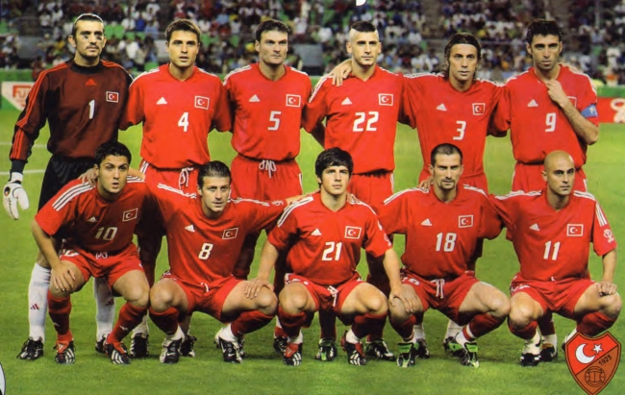

Above is the Turkish team who came
3rd in the World Cup.
Just before they played
Costa Rica In the play-off!

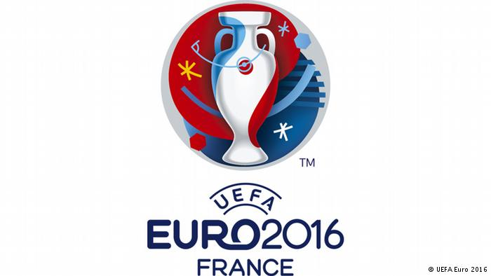 EURO 2016
Turkey are in Group D. With them are Croatia, Czech Republic and Spain. They play their 1st match of the group stages against Croatia on the 12th of June at 4:00pm. They play in the stadium Parc Des Princes in Paris, which is normally PSG’s stadium (Paris St-Germain.)
Turkey will be depending on their three main players Arda Turan, Hakan Calhanoglu and their keeper Volkan Babacan. They expect them to make a big difference. They have chosen the 4-5-1 formation.
They have picked Arda Turan as their captain for the entire tournament but if he gets injured they will use their second captain Mehmet Topal.
They will be using a new kit for the Euro 2016 campaign. Red jersey, black shorts and black socks. This is the 1st major tournament they have qualified for in 8 years!! This is their 4th time qualifying for the tournament. They also qualified in 1996, 2000, 2008 and now 2016.

Group D

Pos | Team | Pld | W | D | L | GF | GA | GD | PTS
1 | Croatia | 3 | 2 | 1 | 0 | 5 | 3 | +2 | 7
2 | Spain | 3 | 2 | 0 | 1 | 5 | 2 | +3 | 4
3 | Turkey | 3 | 1 | 0 | 2 | 2 | 4 | -2 | 3
4 | Czech Republic | 3 | 0 | 1 | 2 | 2 | 5 | -3 | 1
Here is the Group as it finished.

Records!!!

Turkey have only ever gone 3 matches without conceding a goal. Those matches were against Chile and Honduras.
During the very first year that the Turkish team were developed (1923-1924), they only played 5 international matches against Estonia, Finland, Latvia, Poland and Romania. They managed to get 13 goals in only 5 games and it was a surprising one because they only scored in 4 of the games. They did not manage to score a goal against Poland.
Their leading top goal scorer is Hakan Sukur with 53 goals in 15 years and 6 months!!!

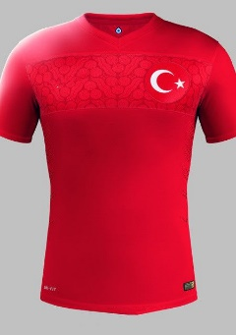 W,L and D 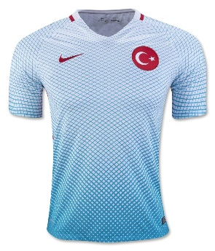

Turkey have played 574 international games. They have lost 6 more than they have won! They have lost 224 meaning they have only won 218 and the rest were all drawn. Their average goals in a match are 1.29 but they concede 1.40 per match :( They have conceded a whopping 806 goals against them!!! And only scoring 743 goals against their opponents. Which means there is a 63 goal difference.

By Joe Condon!
