Facts on the Mona Lisa

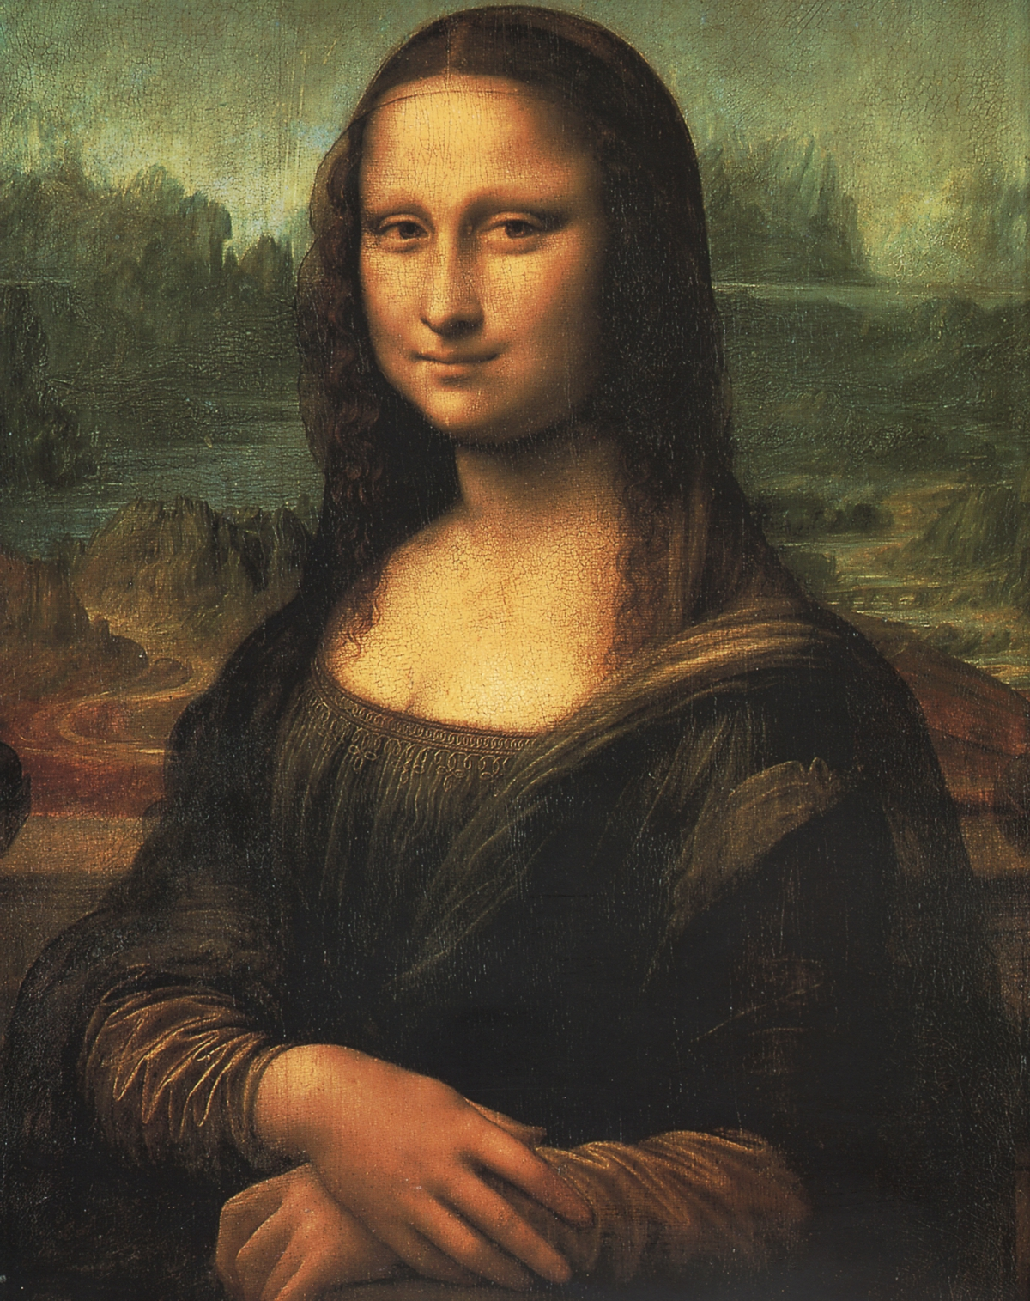
> The Mona Lisa was thought to be Lisa Gherardini.

> The Mona Lisa was painted by Leonardo da Vinci.

> The Mona Lisa was painted from 1503 to 1506.

> The Mona Lisa was stolen by Vincenzo Peruggia.

> Peruggia was spotted trying to sell the Mona Lisa.

> Someone framed Pablo Picasso on stealing Mona Lisa

> The Mona Lisa is now at Louvre Museum.

> The Mona Lisa is now in bullet-proof glass.

> The Mona Lisa was hit by a stone.

> The Mona Lisa is worth US $100 million today.

By Joshua Clulow.

