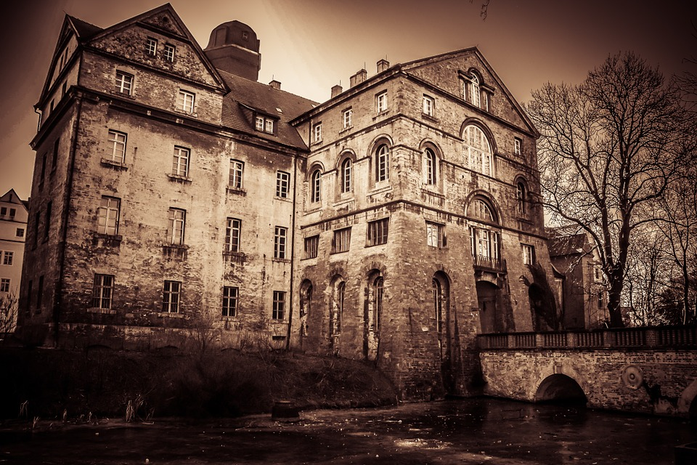
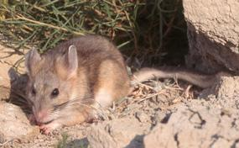
Quieter than
Quieter than a sleeping mouse
Quieter than a library
Quieter than an abandoned house
Or the hopping of the flea
Quieter than a Sunday mass
Quieter than leaking gas
Quieter than a moonlit night
Or Conor Mcgregor when he lost the fight.
BY:AARON PERRY

