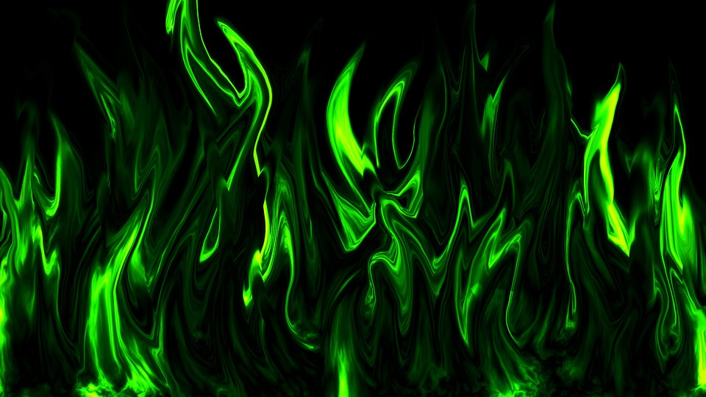Quieter than

Quieter hana sleeping mouse
Quieter than a library
Quieter than an an abandoned house
Or the hopping of a tiny flea

Quieter than electric cars
Quieter than a baby asleep
Quieter than an astronaut on Mars
Quieter than a mouse goes peep

By Gavin Mc Barron

