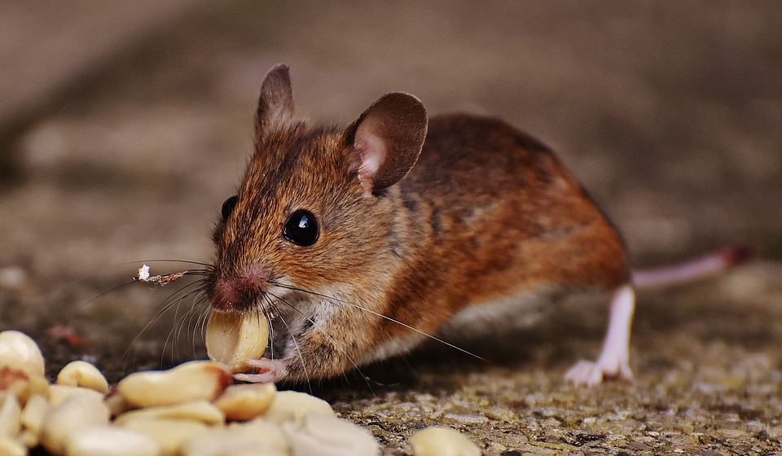Quieter than

Quieter than a sleeping mouse
Quieter than a public library
Quieter than an abandoned house
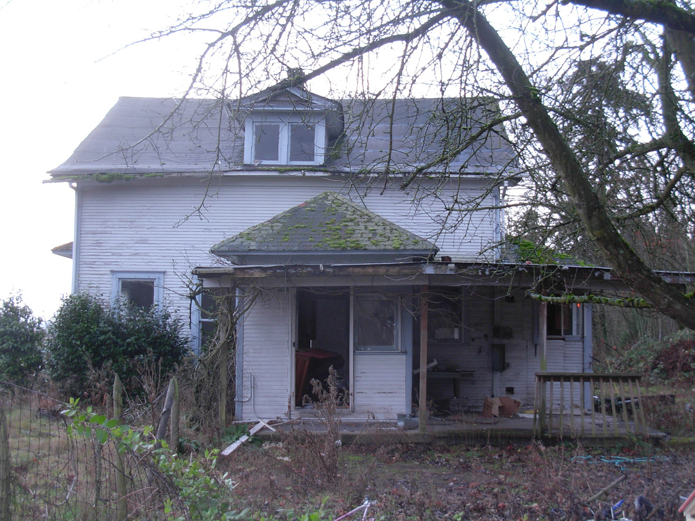
Or the hopping of a tiny flea

Quieter than tiptoes on the stairs
Quieter than a fly
Quieter than a nail
Quieter than a pencil

By Joshua Kondopa Bareba

