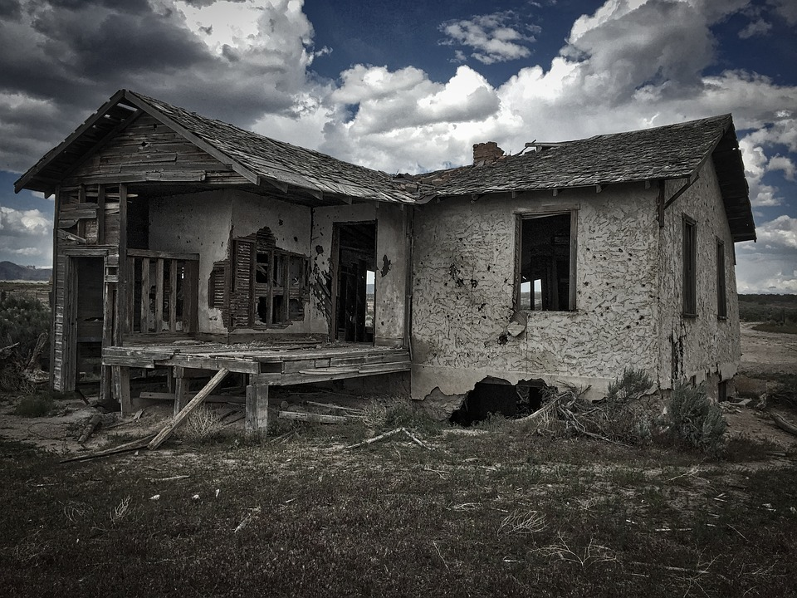
Quieter Than
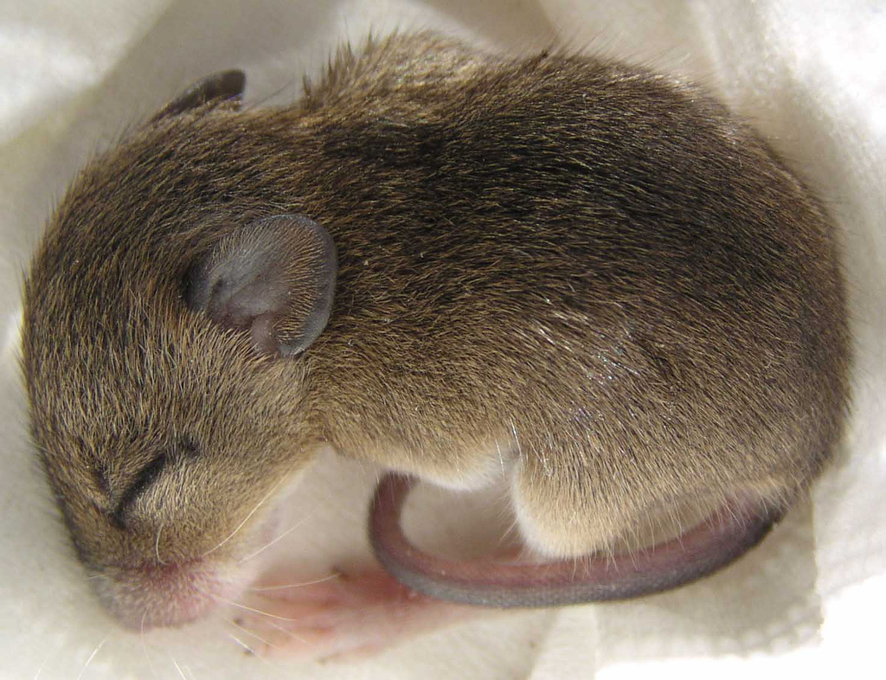
Quieter than a sleeping mouse,
Quieter than a library,
Quieter than an abandoned house
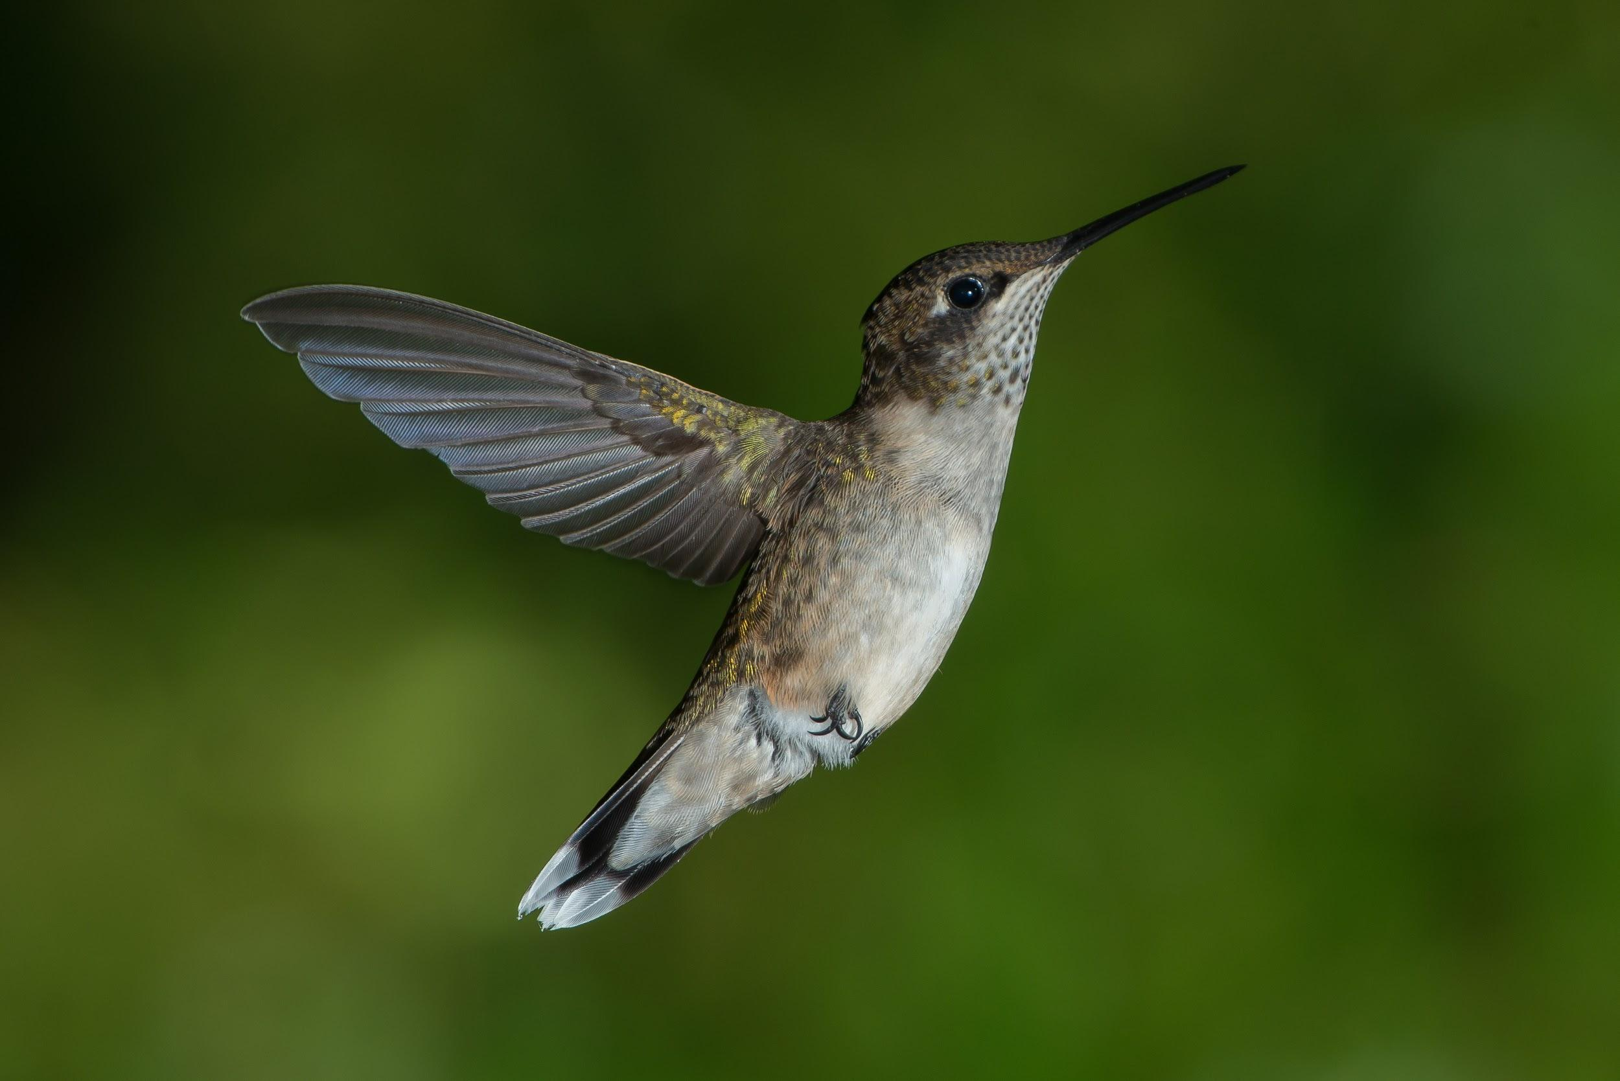
Or the hopping of a tiny flea.

Quieter than the flap of a hummingbird's wing,
Quieter than a leaf falling from a tree,
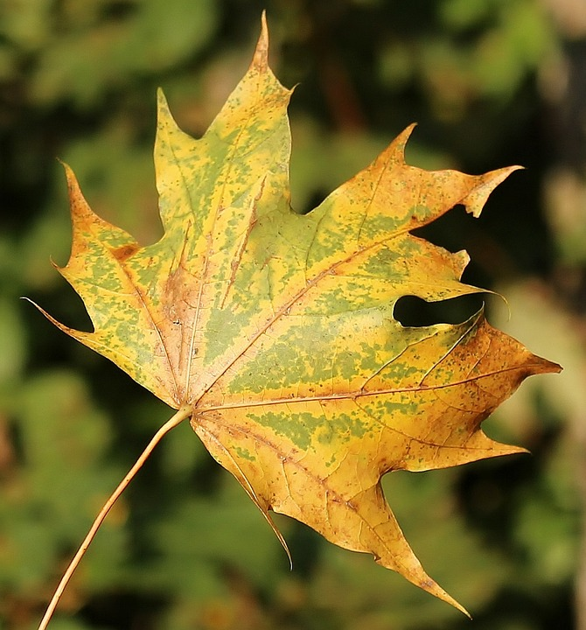
Quieter than a mute person sing
Or plankton moving through the sea.

By William George

