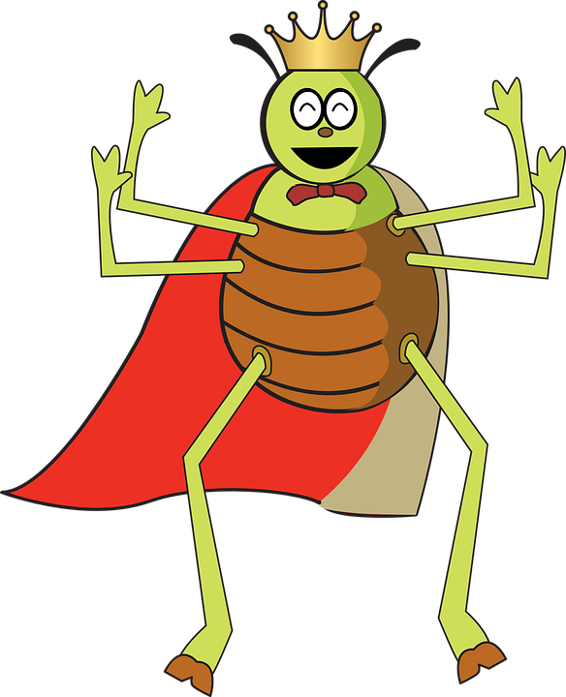
Quieter Than

Quieter than a sleeping mouse.
Quieter than a library.
Quieter than a abandoned house.
Or the hopping of the tiny flea.

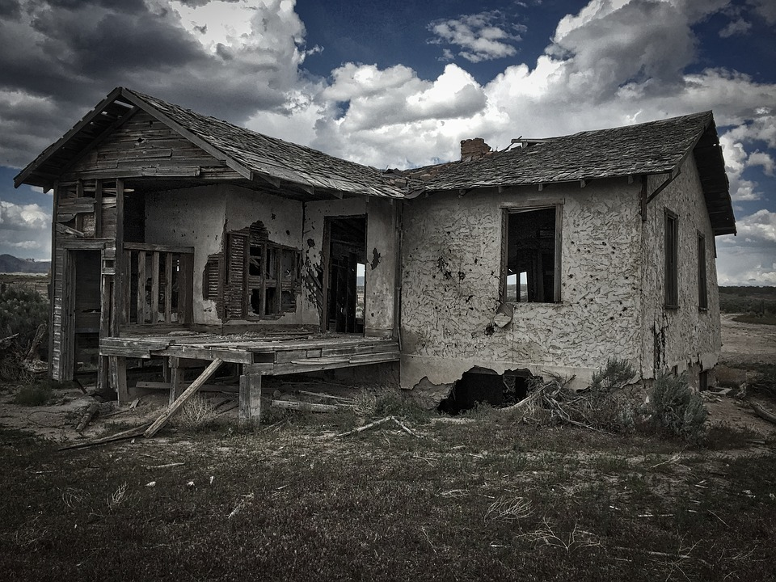
Quieter than the steam of the tea.
Quieter than the knitting of the wool.
Quieter than a frog when it leaps.
Or the mouse when it weeps.

By CIan Byrne

