Quieter than
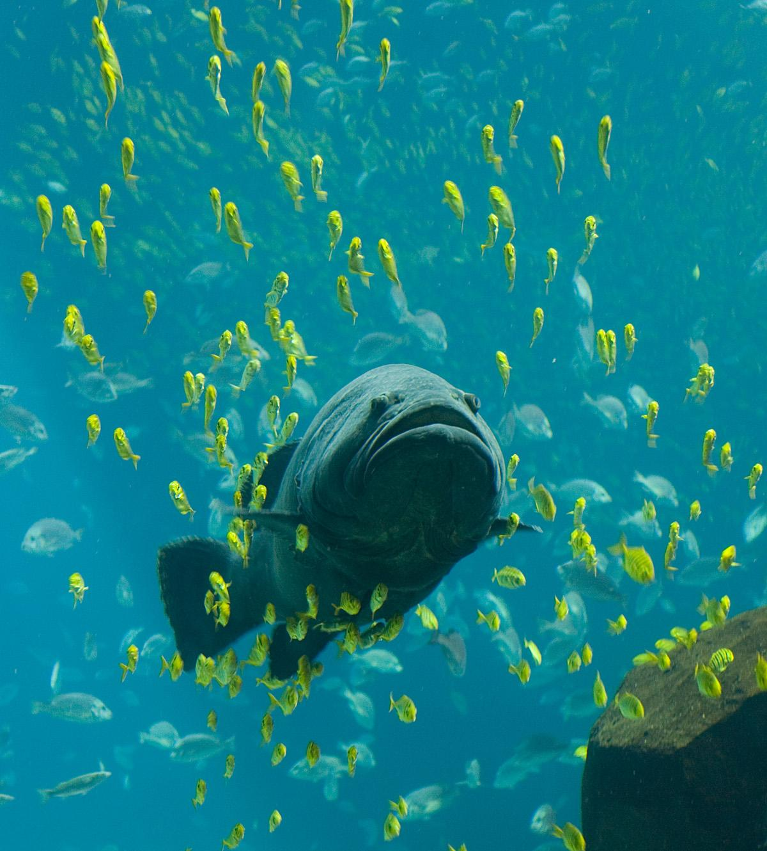
Quieter than a car parks
quieter than a fish swims
quieter than a bird flies
quieter than a person sleeping
quieter than a abandoned house
quieter than a car turns off
quieter a mouse
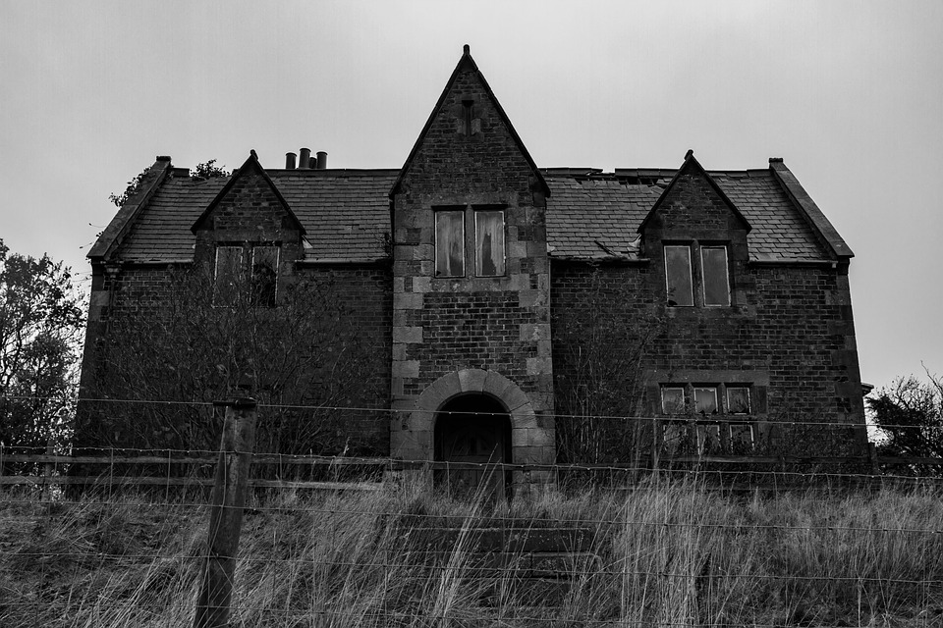
By Francis Touhey

