1916 Rising by Cian Byrne
In 1916 Ireland was controlled by the British Empire.
Many Irish people believed that Ireland should be free country and they decided that they would have to fight for freedom.

It was April 24 Easter Monday when the fighting began the rebels were at a big disadvantage because they had far fewer men.
But they decided to go ahead with the battle anyway.
They captured many important buildings around Dublin and decided they would hold their ground.
The rebellion was not very well organised and far less people turned up to fight than the rebel leaders had hoped. This happened for many reasons. The rebels had problems communicating with other groups around the country to organise the attack and there were disagreements among the rebel leaders. The main rebel group involved in the attack were Irish volunteers.
The largest and most well-known building they took was the GPO. The GPO was located on Sackville street one of the busiest street in Dublin. Today this is called O’Connell Street.
This building was to be the headquarters of the rebellion.
This building was very important for number of reasons. First of all it was much known and would draw attention to the cause. Secondly being a post office it would disrupt communication all over the city and the country and make things difficult for the British authorities.
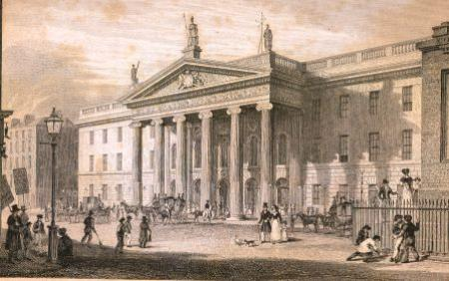
The rebels raised an Irish tricolour above the GPO and the leader of the rebels Padraig Pearse went out onto the steps of the building to read and Proclamation of the Irish republic a document that declared Ireland to be its own nation independent from Britain.
The British Army were caught off guard at first. They had not been expecting an attack. The government had been distracted by the events of World War 1 which was going on at the same time.
Despite this they were still a very powerful army and they quickly began to fight back against the rebels. They had many important advantages. They were very well trained professional army. The rebels were not full time soliders.The British also had superior weapons and unlimited ammunition while the rebels had very limited weaponry available to them. They began to assault the GPO by firing explosive shells and putting the rebels under heavy gunfire.
The rebels held on as long as they could but they eventually were forced to surrender. The British took the GPO and Pearse surrendered on behalf of the rebels on Saturday the 29th of April.
One of the leaders of the rebels was Padraig Pearse He was from Dublin and he was very senior member of the Gaelic league organisation which promoted and celebrated traditional Irish culture.
He believed strongly in the Irish language and thought it was very important for Irish people to be able to speak their own language .
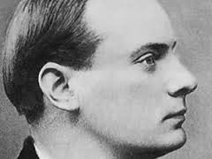
He started his own school called St.Endas school that taught children in both Irish and English. It was one of very few bilingual schools in Ireland at that time.
HE was a very important part of the independence movement. He thought it was very important for Ireland to be its own republic because he had such respect for the Irish language and traditional Irish culture. He strongly believed it was necessary to use force to achieve this goal. He was a leading member of the Irish volunteers and the Irish republican brotherhood.
Pearse and the rest of the leaders were executed by the British army soon after he surrendered on the 29th of April.
Cian Byrne.

