I WILL PUT IN THE BOX

By Aaron mulcahy

I will put in the box
The soothing sound of the owl hooting
The rustling of the grass
The howl of the pack of wolves as they hunt their night time feast
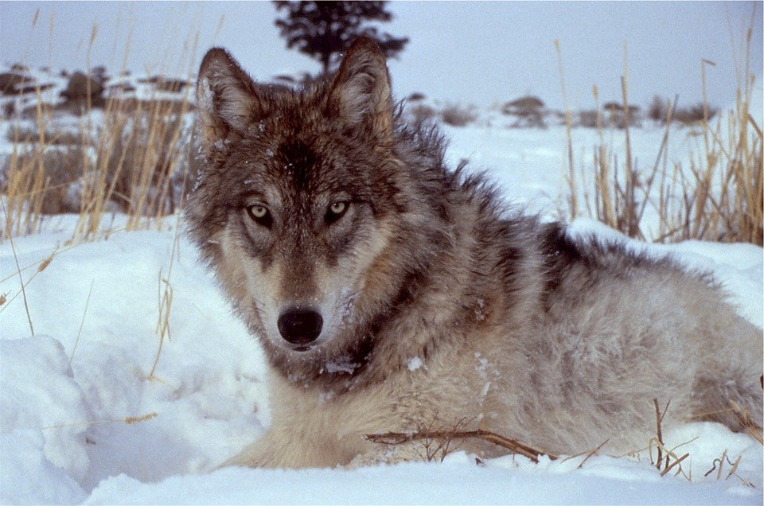
I will put in the box
The rustling of the campers
as they start to sleep
The swooshing of the shooting star
As the willow starts to weep
