Albania Euro 2016
Qualifying Group I
P W D L GD Pts
Portugal 8 7 0 1 6 21
Albania 8 4 2 2 5 14
Denmark 8 3 3 2 3 12
Serbia 8 2 1 5 -5 7
Armenia 8 0 2 6 -9 2
Results
Denmark 2-1 Albania
Albania 1-1 Serbia
Serbia 0-3 Albania (This game was forfeited because crowd trouble)
Albania 2-1 Armenia
Denmark 0-0 Albania
Albania 0-1 Portugal
Albania 0-2 Serbia
Armenia 0-3 Albania
This is the first time Albania qualified for the a major final
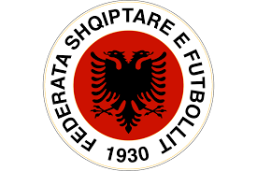

Albania football federation :founded 1930
Manger: Gianni De Biasi
Star player: Rey manaj
Captain : Loilc cana
Their first international match was against Yugoslavia seventeenth of October 1946 (lost 3-2)

Euro Group A
France Switzerland
Romania Albania

Fixture
June 11th Albania v’s Switzerland Lens 2pm
June 15th Albania v’s France Marseille 8pm
June 19th Albania v’s Romania Lyon 8 pm

