The magic football

I shall put in the football
The bending free kicks from Beckham
The leadership from GERrard
The hand of god from Maradona
And the anger from Zidane’s headbutt

I will put in the football
The skills of Ronaldinho
The spaghetti legs from Bruce Grobbelaar
The pace of fat Ronaldo
The play making off Iniesta

I shall put in the football
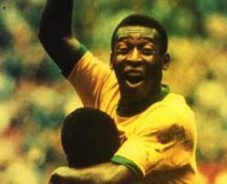
The power shots from giggs
The celebrations from cole
The bicycle kicks from rooney
The star gameplay from pele

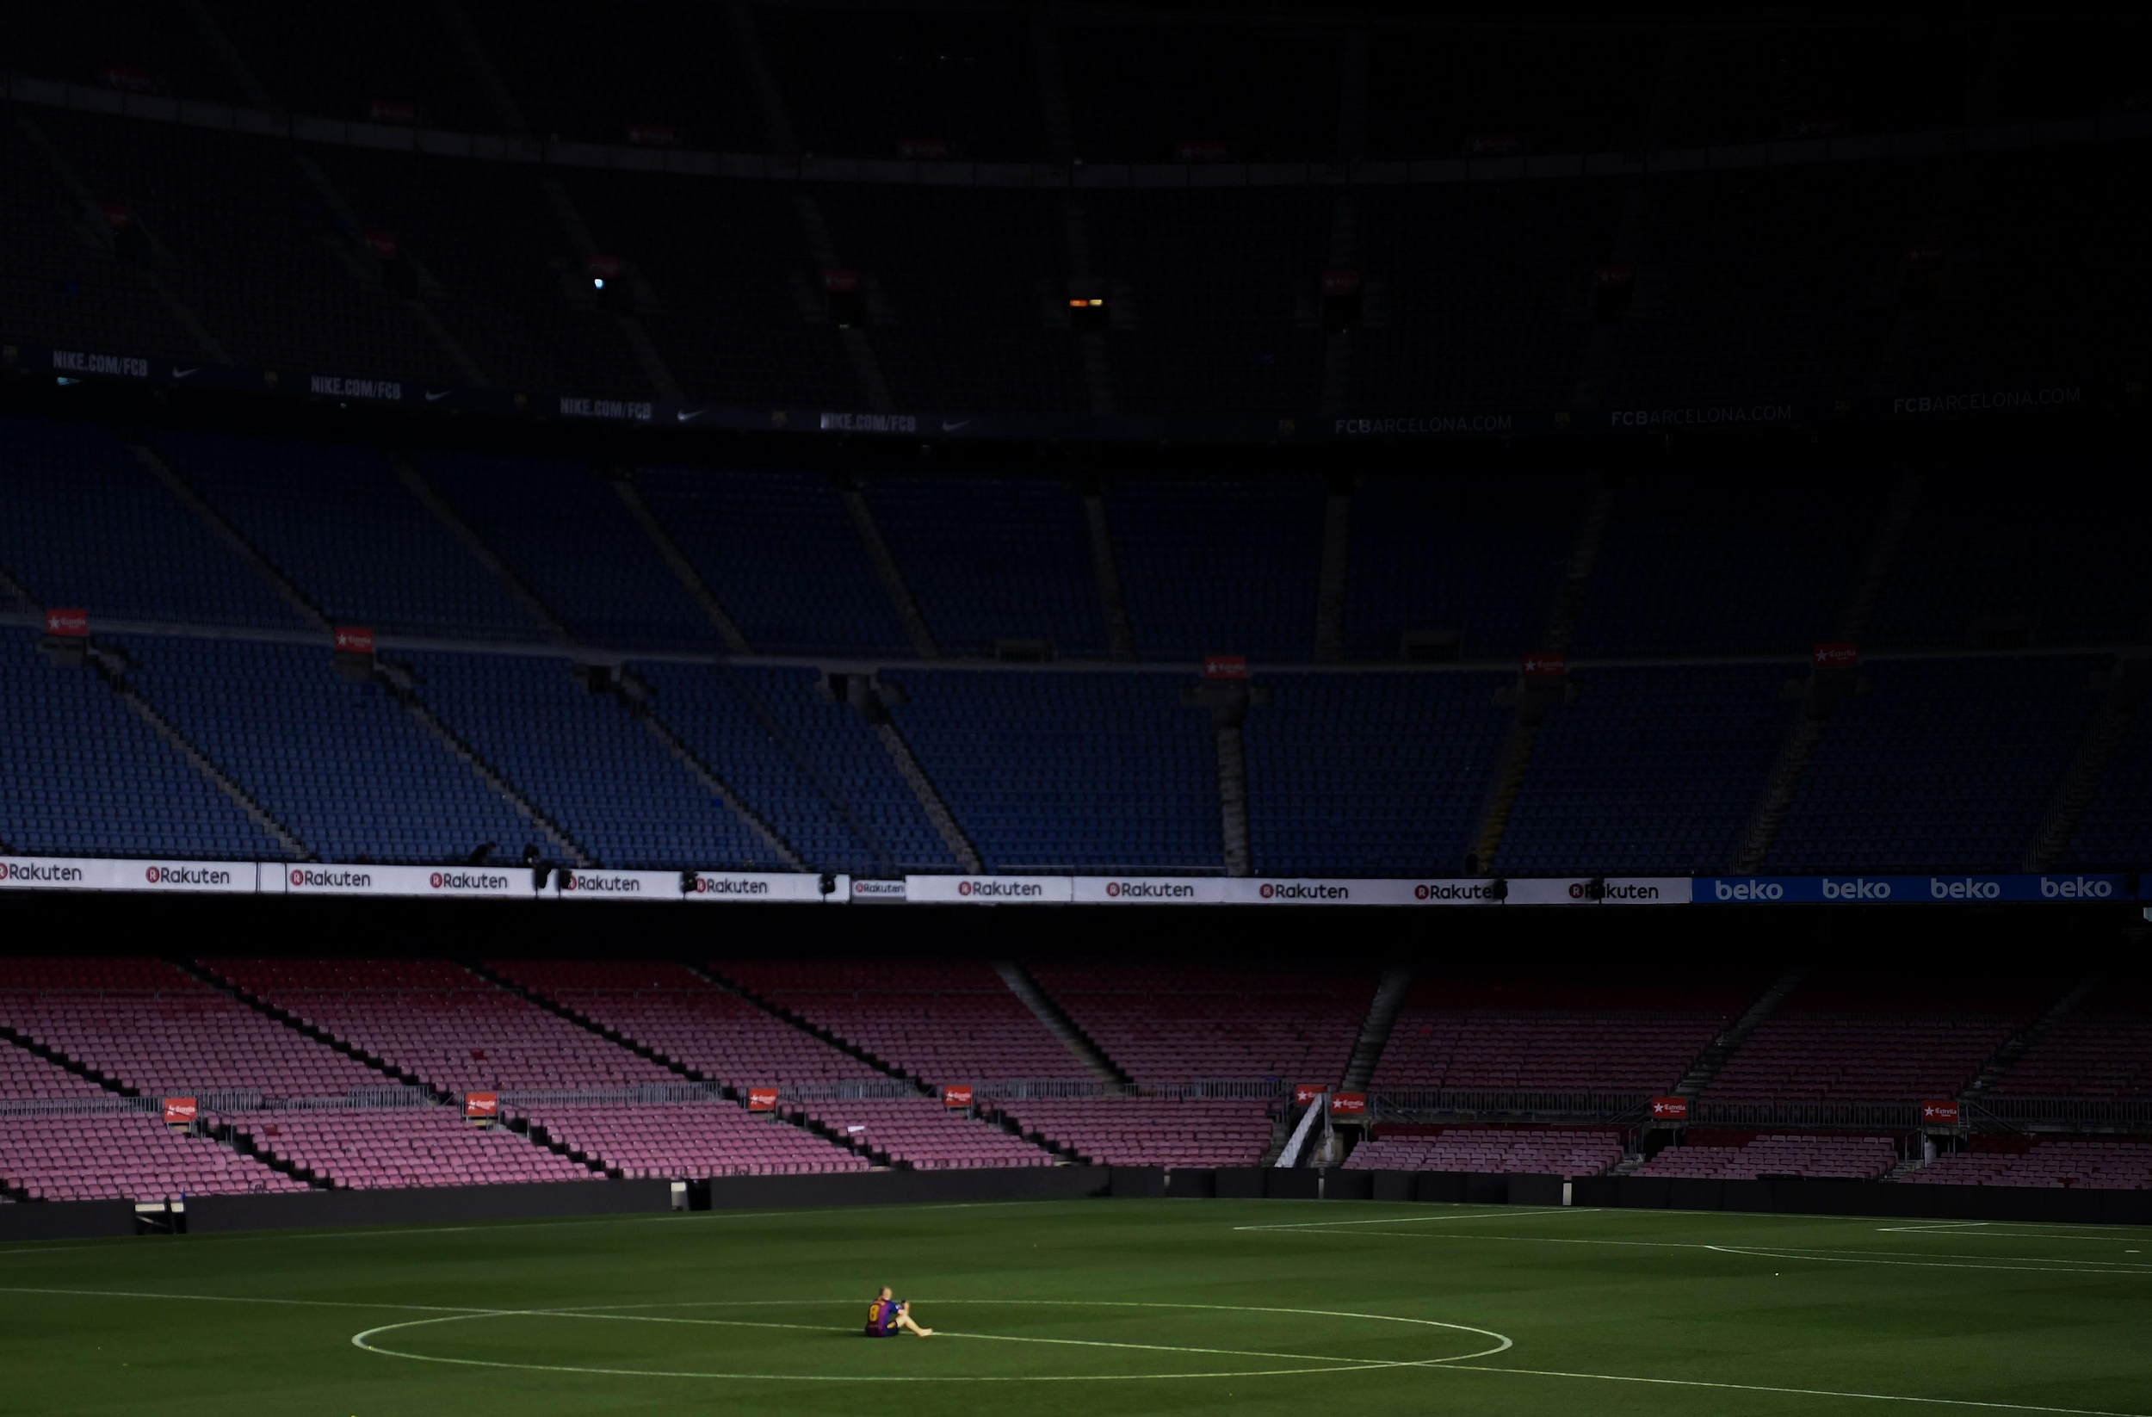
By Alistair Mhondiwa

