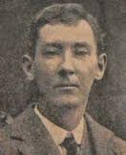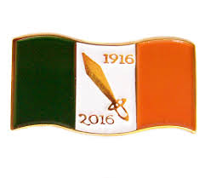
1916
&
Peadar Kearney
Background:
Kearney was born at 68 Lower Dorset street Dublin in 1883. His father was from Louth and his mother was originally from Meath. He was educated at the Model school, schoolhouse lane and St Joseph’s Christian brothers school in Fairview Dublin. He left school at the age of 14, becoming an apprentice house painter.

Peadar joined the Irish volunteers when they were founded in 1913. He was also an organiser for the IRB, travelling around Leinster on his bicycle. He took part in the Howth and Kilcoole gun running’s in 1914.

1916 Peadar Kearney was in England touring with the Abbey Company. When he received word he was needed back in Dublin, as plans for the Rising were maturing. He travelled back on a coal boat through a storm. On Easter Monday 1916 he took his post under Commandant Thomas Mc Donagh in Jacobs Biscuit Factory.
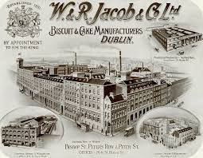
Jacobs Biscuit Factory:
Jacobs Biscuit Factory was used by the rebels in 1916. Jacobs was a very large employer of Dublin people around this time. The Jacobs family where Quakers, where they had a biscuit factory in Waterford. 1852 they moved to Bishop Street Dublin with their new business partner and a fellow Quaker William Bewley. Along with 150 volunteers from the 2nd battalion, Major John Mac Bride (who fought against the British in the Boer war) was Thomas Mac Donagh 2nd in command.
The volunteers placed snipers on the roof of Jacobs Biscuit Factory, where they could see the military barracks of Portobello, Dublin Castle and Ship street. A 15year old boy Vinny Byrne was also part of the rebel force in Jacobs. He later went on to become one of Michael Collins most trusted men. Vinny Byrne was a member of a special group known as the 12 Apostles. Who went on to kill 14 British agents in one day.
Over Easter week not much fighting took place in and around Jacobs. A request came from Michael Mallin (at St Stephens Green) and Eamon De Valera (at Bolands Mill) for extra men and ammunition. Major John Mac Bride went out with his men on missions to help, but was cut off by the British soldiers, who surrounded all roads that led to St Stephens Green and Bolands Mill.
When the Rising came to an end, Thomas Mac Donagh secured terms of surrender from the British General in charged (Lowe). He then went on to secure surrender from other garrisons like, The South Dublin Union and Marrowbone Lane.

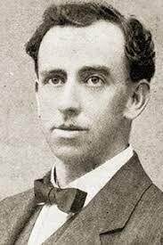

Thomas Mac Donagh was executed for his part in the Rising on May 3rd 1916.

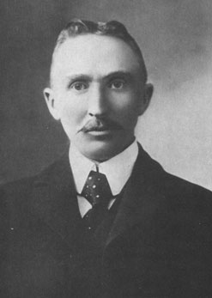
Major John Mac Bride was also executed for his part on May 5th 1916.

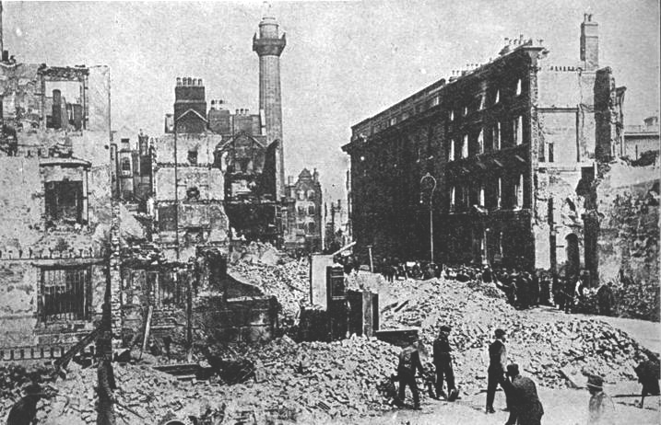
Peadar Kearney
&
Patrick Heeney
Peadar Kearney an IRB member (Irish Repuplic Brotherhood), author of many popular songs such as “Down by the Glenside, The Tri-Coloured Ribbon, Down by the Liffey Side and Erin Go Bragh”. Erin Go Bragh was the text on the Irish national flag before the adoption of the tricolour.
Kearney also produced the words of “The Soldiers Song” working with Patrick Heeney, who was mainly responsible for the melody. The original text was written in English and later translated into Gaelic. The words and the music may have been written as early as 1907.
It has been said that The Soldiers Song was one of the most popular songs sung by the Republicans during the Easter week. It became increasingly popular as a marching and rallying song among the volunteers between 1912 and 1916. It confirmed they were soldiers rather then rebels. On the belts of their uniforms the volunteers wore the words “Oglaigh na hEirann, Soldiers of Ireland. After the Easter Rising the “The Soldiers Song” came to be widely used.
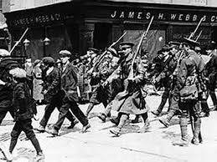
Kearney died in relative poverty in Inchicore on the 24th November 1942, as he was not paid for his contribution to the song. He is buried in Glasnevin Cemetery. A wall plaque on the west side of Dorset street commemorates his birth there.

1916 And Peadar Kearney Project by Conall Carey

