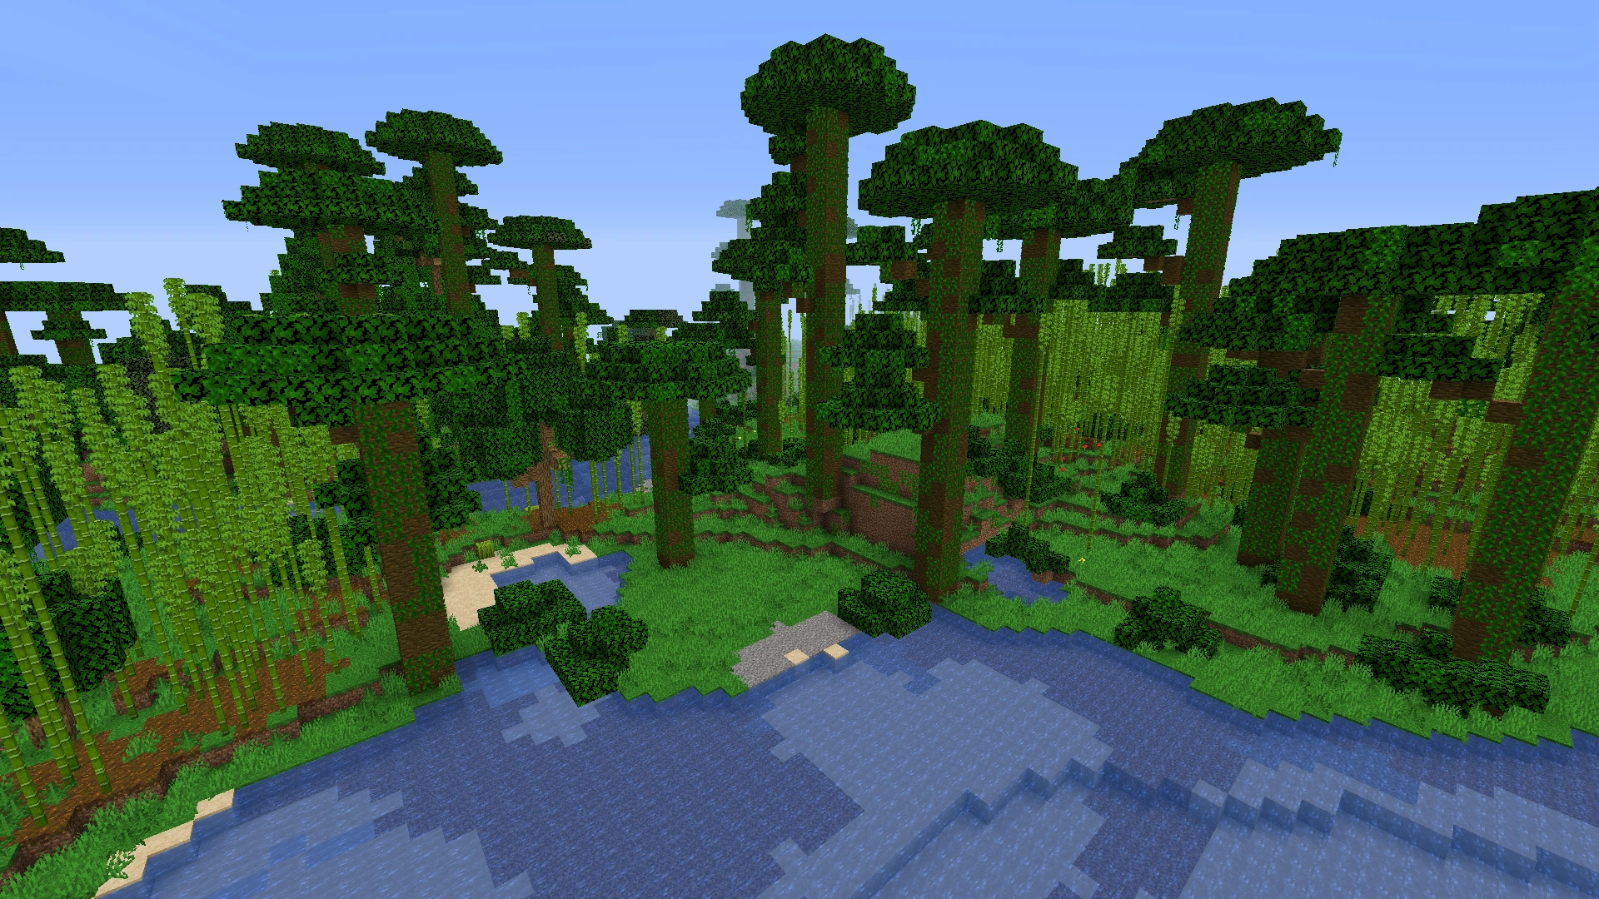 World
I will put in this world
A jungle with great trees
the fur of a lion
The caw of the parrot
And the slithering of a snake

I will put in this world
A city with tall buildings
The honk of car
The busy office building
And the sound of people walking down the road
