MY 1916 PROJECT

BY CORMAC O'SULLIVAN
1916 Rising Facts

- Irish tricolours had been mentioned in 1830 and 1844, but 1848 eventually saw it flown at meetings all over the country, side by side with the French tricolour, to celebrate the revolution that had just taken place in France.

  - Ireland at the time was deeply divided between Catholic and Protestant, and suffering hugely from the effects of the Great Famine, which killed a million Irish people and caused another million to emigrate

  - On Easter Monday, April 24th 1916, the IRB, Irish Volunteers and Irish Citizen Army flew the Irish tricolour from the top of the GPO in Dublin.

  - The green in the flag symbolises Irish republicanism dating back to the Society of United Irishmen in the 1790s and beyond.

  - The orange in the flag represents the Protestant minority in Ireland. It was included in the Irish flag in an attempt to make Irish Protestants feel included in the Irish independence movement.

  - The white in the centre symbolises the hope for a lasting peace between the two parts on the island of Ireland.

  - There are special rules for using the national flag. The main rule is that no other flag should be flown above it.

  - The children were used for newspaper boys to spread the word of the rising far and wide.

The Proclamation

The seven signatories of the Irish proclamation are:

Padraig Pearse
James Connolly
Thomas Clarke
Sean MacDiarmid
Joseph Plunkett
Thomas McDonagh
Eamon Ceannt

All of them were executed by the British British Government for their efforts in trying to secure a free Ireland.
A Post's copy is one of the few to have survived the turmoil of Easter Week and the passage of nearly a century. It is now public on display in the An Post Museum in the G.P.O.

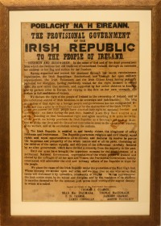

Padraig Pearse

Padraig Pearse was born in Dublin Great Brunswick Street. His mothers name was Margaret Pearse and his fathers name was James Pearse. Pearse was a teacher, poet, barrister and writer. In July 1914, Pearse was made a member of the Supreme Council of the Irish Republican Brotherhood (IRB).

Padraig pearse was born on November, 10th 1879
and died on May, 3rd 1916 Kilmainham Gaol.

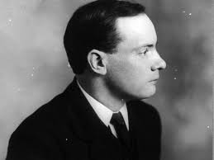

James Connolly

Born in Edinrouhgh to Irish immigrant parents. Connolly first came to Ireland as a member of the British army. Age 14, he forged documents to enlist to escape poverty and was posted to Cork, Dublin and later the Curragh in Kildare. James Connolly got badly wounded at the GPO.

James Connolly was born on June 5th, 1868
and died on May 12th, 1916 Kilmainham Gaol.

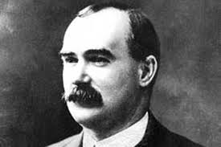

Sean McDiarmada

Born in Leitrim, he emigrated to Glasgow in 1900 where he worked as a tram conductor, and from there came back to Belfast in 1902. Sean McDermott Street in Dublin is named in his honour as is Mac Diarmada rail station in Sligo, and Páirc Seán Mac Diarmada, the GAA ground in Carrick-on-Shannon. Sean MacDermott tower in Ballymun, which was demolished in 2005, was also named after him.

Sean McDiarmada was born on January 27th, 1883
and died on May 12th, 1916 Kilmainham Gaol.

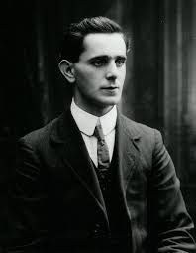

Thomas Clarke

Born on the Isle of Wight to Irish parents, Clarke’s father was a sergeant in the British army who was stationed there. The family moved to South Africa and later to Dungannon, Co Tyrone, where Clarke grew up from about the age of seven, attending Saint Patrick’s national school.In 1882, he emigrated to America. During his time there he joined the republican organisation Clan na Gael and, as a proponent of violent revolution, he would serve 15 years in British jails for his role in a bombing campaign in London.
Thomas Clarke was born on March 11th, 1858
and died on May 3rd, 1916 Kilmainham Gaol.

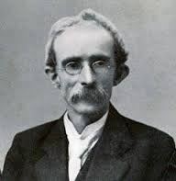

Joseph Plunkett

Born in Dublin, he was the son of a papal count, George Noble Plunkett.
Plunkett was educated by Jesuits at the Catholic University School, Belvedere College and Stonyhurst College in Lancashire, England. MacDonagh was to become a close friend, as both were interested in poetry, religion and mysticism. He was elected to the provisional committee of the Irish Volunteers in 1913 and later became a member of the IRB and fully committed to armed revolution. In April 1915 Plunkett went to Germany to assist Roger Casement in procuring arms and assistance for the Easter rebellion.

Joseph Plunkett was born on November 21, 1916
and died on May 4th, 1916 Kilmainham Gaol.

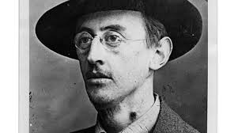

Thomas McDonagh

A native of Tipperary, MacDonagh trained as a priest but like his parents became a teacher, and was on the staff at St Enda’s, the school he helped to found with Padraig Pearse. A gifted poet, writer and dramatist, in 1909 he was a founding member of the Association of Secondary Teachers of Ireland and also was active in setting up the Irish Women’s Franchise League in 1911 which promoted Irish nationalism and the cultural revival.

McDonagh was born on February 1st, 1868
and died on May 3rd, 1916 in Kilmainham Gaol.

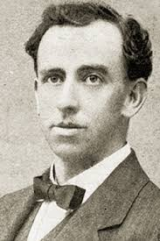

Eamon Ceannt

Son of a RIC officer, Ceannt was born in the police barracks at Ballymoe, Co Galway. He was in command of the 4th Battalion of Irish Volunteers at the South Dublin Union in 1916, He faced the firing-squad at Kilmainham Gaol on May 8, 1916. which is now the site of St James’s Hospital. Ceannt was a founder member of the Irish Volunteers and a signatory of the Proclamation of Independence.

Eamon Ceannt was born on September 21st, 1881
and died on May 8th, 1916 Kilmainham Gaol.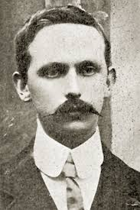

By Cormac O Sullivan

