James Connolly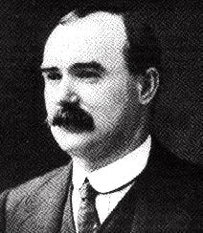
James Connolly was born on June 5, 1868, at 107, the Cowgate, Edinburgh. The nickname of the slums they lived in were known as Little Ireland .He lived with his Mother Mary and his Father John. He had two older brothers. They were called John and Thomas. His parents were from County Monaghan and emigrated to Scotland in the 1850’s. His father was a dung collector and his mother was a servant. His mother died at a young age because she suffered from chronic bronchitis.
James Connolly went to St Patricks Catholic Primary School in the Cowgate until he was ten years old. . When he was ten years old, he got a job with Edinburgh's Evening News where he worked as a 'Devil', cleaning inky rollers and fetching beer and food for the grown up workers. James Connolly joined the British army when he was 14 years old.All of his service in the British Army was in Ireland. This is when he met his future wife Lillie Reynolds. He used the surname Reid when he was in the Army. When he was in the British Army he realised how badly the Irish were treated, not just by the Army but also by the landlords who were unfair to the Irish people. He left the British Army when he was 21 and a year later in 1888, he moved back to Scotland and brought Lillie with him. When he moved back to Scotland, James Connolly worked as a labourer with his Brother and his Father and also worked as a carter. In 1889 he got married to Lillie in Perth and he used his real surname Connolly. He became interested in socialism. He joined socialist and trade union circles and became secretary of the Scottish Socialist Federation and became part of the Independent Labour Party which was set up in 1893 by Kerr Hardie. In 1894, Connolly had lost his job with the corporation. He opened a cobblers shop in February 1895 at number 73 Bucclevch Street. The business was not very successful. At the invitation of the Scottish Socialist, John Leslie, he came to Dublin in May 1896 as paid organiser of the Dublin Socialist Society for 1 pound a week. James and Lillie Connolly and their three daughters, Nora, Mona and Aideen set sail for Dublin in 1896, this is where he founded the Irish Socialist Republican Party in May 1896. In 1898, Connolly had to return to Scotland on a lecture and fund-raising tour. When James Connolly was in Ireland he had founded The Workers' Republic newspaper, the first Irish Socialist paper, from his house at number 54 Pimlico where he lived with Lille Nora, Mona and Aideen and six other families. There was 30 people living in the house in total! In 1903 Connolly, with his wife and children went to the U.S.A. There he became a member of the Socialist Labour Party and the Industrial Workers of the World movements. He was also the founder of the New York Socialist Federation. In 1910, he returned to Ireland where he found that his Irish Socialist Republican Party had fallen completely apart. He went to work straight away and organized The Socialist Party of Ireland.
He also joined the Irish Transport and General Workers Union which had been founded in 1907 by James Larkin. In 1911, Larkin was to appoint Connolly as organizer of the ITGWU in Belfast. The two men then went forward and founded the Irish Labour Party in 1913.The British had promised the Irish home rule. They were using their best efforts to organize and unionize the Irish working men and in 1913 – 1914 along with the employers, they took part in what has become known as the Great Lock-out. This dispute, which lasted from 26th August 1913 to 18th January 1914, was the most severe face to face stance between Bosses and Workers that Ireland had ever experienced. In 1914 James Connolly founded the Irish Citizen Army at Liberty Hall. The ICA was established to defend the rights of the working people.
In October 1914, Connolly returned permanently to Dublin and brought back the newspaper The Workers' Republic that December because his other newspaper called The Irish Worker was disallowed.
In The Workers' Republic newspaper, Connolly published articles on guerrilla warfare and continuously attacked the group known as The Irish Volunteers for their inactivity. This group refused to allow the Irish Citizen Army to have any in-put on its Committee and had no plans in motion for armed action.
1916 James Connolly signs the proclamation in Liberty hall on Easter Monday. He was in command of the Republican Head Quarters at the GPO during Easter Week. On Thursday James Connolly was badly injured.
On Saturday the leaders surrendered to the British. He was arrested following the surrender. On May 9, 1916, James Connolly was propped up in bed before a court-martial and sentenced to die by firing squad. He was being held in the military hospital in Dublin Castle. On May 12 James Connolly was carried on a stretcher to Kilmainham jail. He was strapped to a chair in the prison yard and he was executed.

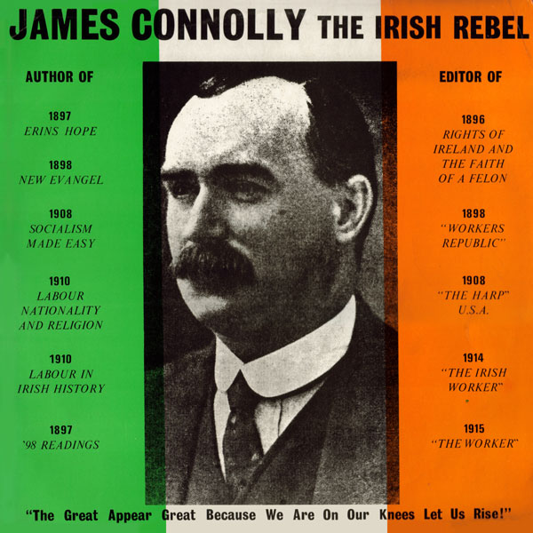
Easter week day by day

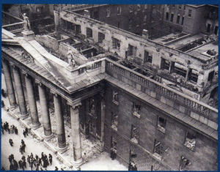
Sunday

An order, cancelling the Easter mobilisation of the Irish Volunteers, appears in the Sunday Independent .Most Volunteers obey it .The IRB Military Council postpones the Rising until the next day.

Monday

Pádraig Pearse reads the proclamation outside the GPO. The Irish Citizen Army and the Irish Volunteers occupy certain buildings in Dublin.
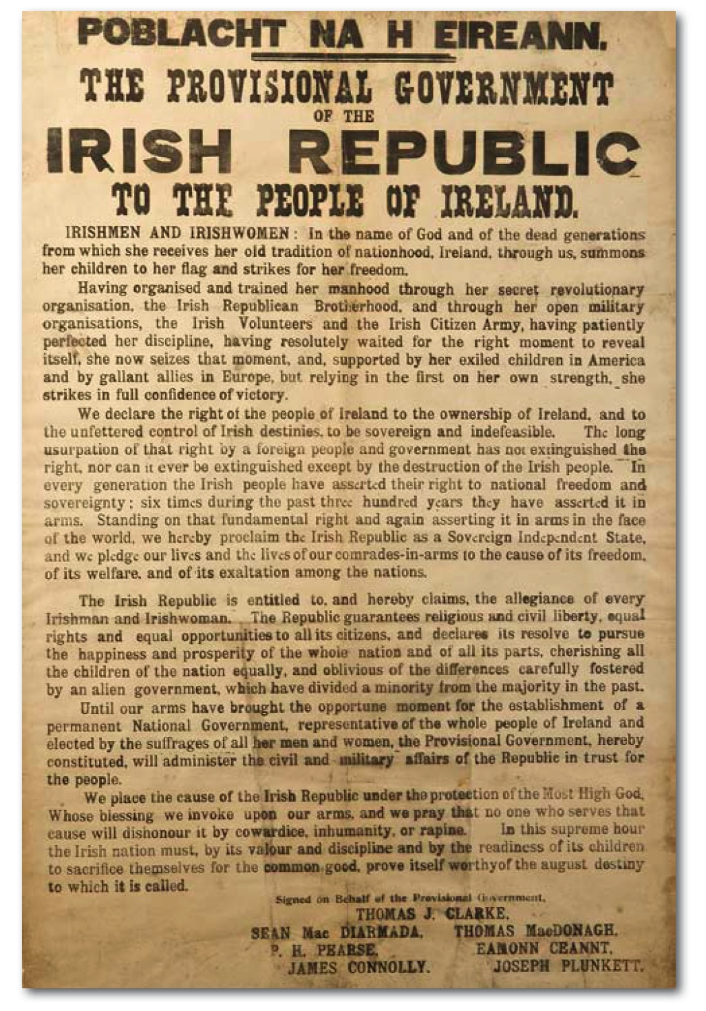

Tuesday
British troops, including the Royal Dublin Fusiliers, engage the Rebels and started to push them back. Lord Lieutenant Wimborne proclaims martial law in Dublin. A British gunboat fires Boland’s Mill.

Wednesday
Liberty hall is blown up by the Helga by the British. A rebel ambush of the Sherwood Foresters at Mount Street Bridge results in large British casualties. Dublin starts experience a food shortage.

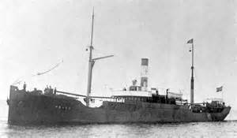
Thursday
British artillery bombards the GPO and Sackville Street. Rebel leader James Connolly has been wounded. Rebels on O’Connell Bridge and Henry Street retreat to the GPO. In County Wexford the rebels occupy Enniscorthy.

Friday
Under intense bombardment, part of the GPO’s roof collapses and the rebels establish a new headquarters in Moore Street. Rebels still holding on at Boland’s Mill, the South Dublin Union, Jacobs Biscuit Factory, The College of Surgeons and the Four Courts.

Saturday
Patrick Pearse orders the rebels to surrender. Some besieged rebel garrisons in outlying districts do not receive the order until Sunday, when they reluctantly lay down their arms.

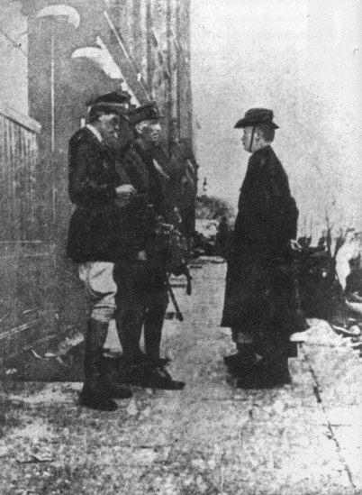

Executed leaders 1916

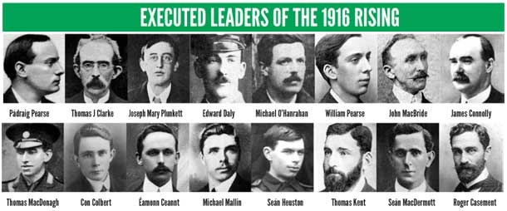

Éamonn Ceannt was executed on 8 May 1916.
Thomas James Clarke: was executed on 3 May 1916.
James Connolly was executed on 12 May 1916. He was the last of the leaders to be executed who signed the proclamation.
Seán MacDiarmada was executed on 12 May 1916.
Thomas MacDonagh was executed on 3 May 1916.
Patrick Pearse was executed on 3 May 1916.
Joseph Mary Plunkett executed on 4 May 1916.
Roger Casement was hanged on 3 August 1916. He was the only leader not to be executed in Ireland
Con Colbert was executed on 8 May 1916.
Edward Daly was executed on 4 May 1916.
Seán Heuston was executed on 8 May 1916.
Thomas Kent was executed on 9 May 1916.
John MacBride was executed on 5 May 1916.
Michael Mallin was executed on 8 May 1916.
Michael O’Hanrahan executed on 4 May 1916.
William Pearse was executed on 4 May 1916.

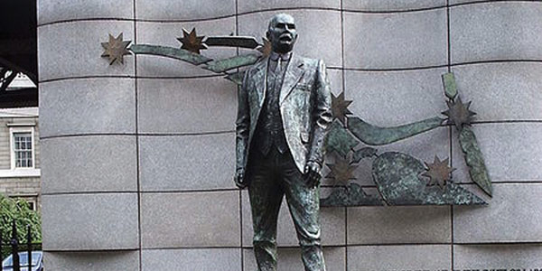

The statue of James Connolly, stands under the bridge at Beresford, in front of Dublin’s Custom House. The creation of artist Eamonn O’Doherty, the statue was commissioned by the Irish Congress of Trade Unions in 1996.

Famous Quotes of James Connolly

The worker is the slave of capitalist society, the female worker is the slave of that slave.
There can be no perfect Europe in which Ireland is denied even the least of its national rights.
If you strike at, imprison, or kill us, out of our prisons or graves we will still evoke a spirit that will thwart you, and perhaps, raise a force that will destroy you! We defy you! Do your worst!
Without the power of the Industrial Union behind it, Democracy can only enter the State as the victim enters the gullet of the Serpent.
Just as it is true that a stream cannot rise above its source, so it is true that a national literature cannot rise above the moral level of the social conditions of the people from whom it derives its inspiration.

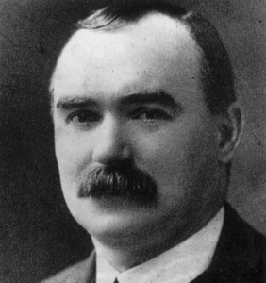

THE END

BY JAMES CONDRON

