Pakistan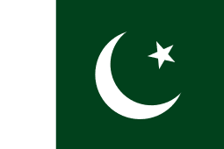

Population: 216.6million 5th most populated country in the world.
Language: most popular is punjabi but there are many others such as sindhi and Saraiki.
Capital city: Islamabad
Size: 34th biggest in the world.

GEOGRAPHY

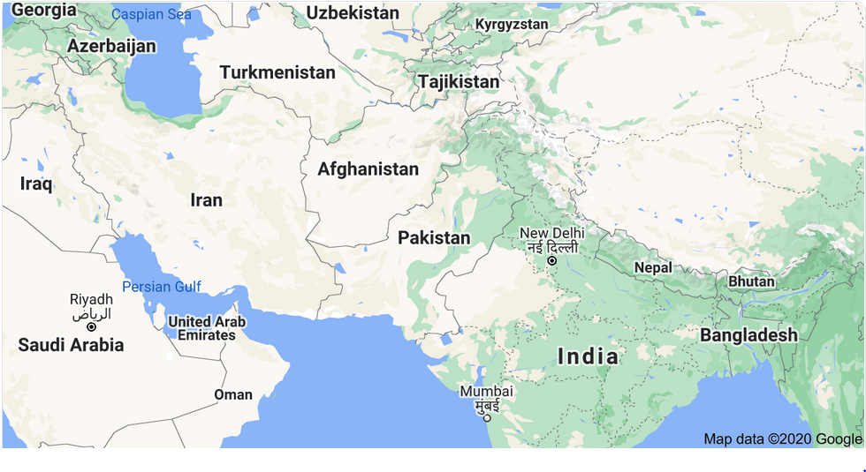

Pakistan is a country in southern Asia. It is next to India, Iran, Afghanistan and China. It is officially called the Islamic Republic of Pakistan. The Arabian Sea, a part of the Indian ocean, lies to the south. The region called Kashmir is to the north east. Pakistan and India have long fought for control of Kashmir.
In northern Pakistan, the Himalayas and the Karakoram Range include some of the highest mountains in the world. Among them is K2, the second tallest peak in the world at 8,611 m
Pakistan has hot summers around 30 degrees and cool or cold winters around 10 degrees and has little rain. But winds called monsoons bring some rain in the summer.

PLANTS AND ANIMALS

Some forests grow on Pakistan's mountain slopes. Grasses, dry bushes, and small trees grow in the rest of the country
Brown bears, black Himalayan bears, wild sheep, and rare snow leopards live in the northern mountains.
The area near the mouth of the Indus River has crocodiles, pythons, and wild boars. Jackals, foxes, wildcats, and many rodents and reptiles live throughout the country.
Snow leopard...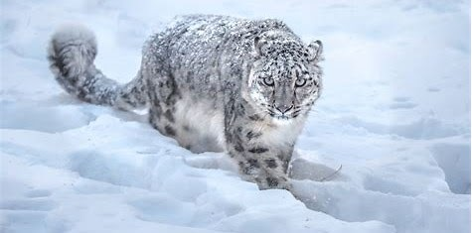

Himalayan black bear.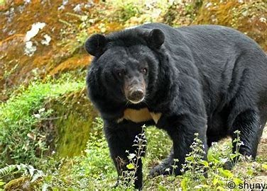
Python.
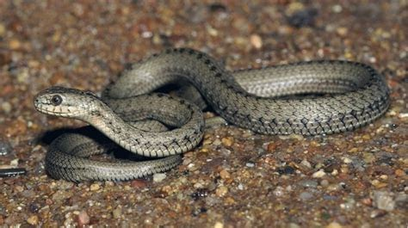

PEOPLE

The people of Pakistan are a mixture of different groups that have come to the region over thousands of years. The five major groups are the Punjabis, the Pashtuns, the Sandhis, the Balochis, and the muhajirs. Punjabis make up about half of the population. Their language called Punjabi, is the most commonly spoken one.

Almost everyone is Pakistan practices Islam. When Pakistan separated from the Hindu state of India, millions of Muslims left India to settle in Pakistan

Economy

Many Pakistanis work in services, including transportation, communications, and government work. Many others work in agriculture. The main crops are wheat, rice, sugarcane, and cotton. Farmers also raise goats, sheep, cattle, and water buffalo.
Agriculture provides raw materials for some of Pakistan's most important industries. Pakistan sells cotton cloth and clothing to other countries. Workers make carpets out of wool and leather goods from hides and skins. Other industries in Pakistan make fertilizers, processed foods, and cement. The country also mines some coal, oil, and natural gas.

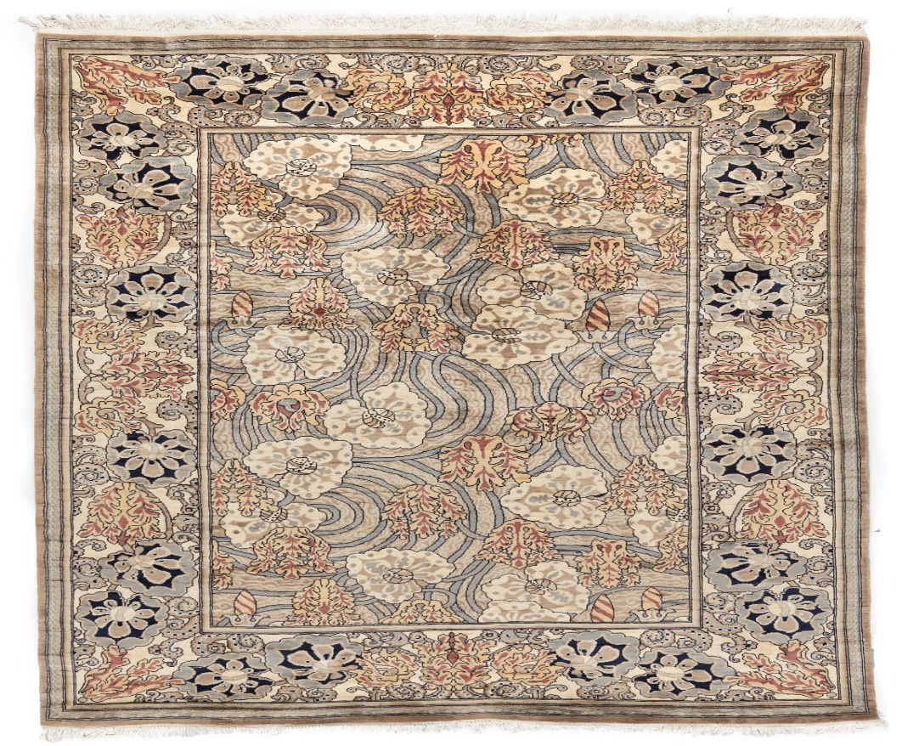
Picture of Pakistan rug……

HISTORY

Pakistan shares much of its early history with India. In the 1850s the government of Great Britain took over India. The Pakistan region was part of British India until the mid-20th century.
In 1947 Britain divided British India into two new countries, Pakistan and India. The parts of British India that had more Muslims became Pakistan the Parts with more Hindus became India. Pakistan included two regions, West and East Pakistan. They were separated by more than 1,000 miles of Indian territory.

When the new boundaries were formed, many Muslims left India for Pakistan and many Hindus left Pakistan for India. Fighting between the two groups left thousands of people dead.

WAR

Both Pakistan and India wanted the region called Kashmir. The conflict over Kashmir led to war between the countries in 1965. Pakistan and India agreed to end the war later that year, but they continued to battle over the territory from time to time. The conflict grew more serious in 1998 when both tested nuclear weapons.

Meanwhile, the people of East Pakistan demanded independence from West Pakistan. A civil war between the two Pakistan’s began in 1971. With the help of the Indian army, East Pakistan became the independent country of Bangladesh in 1972. Pakistan’s territory now included only West Pakistan.

RECENT TIMES

The government of Pakistan changed often after independence. The military seized control several times, but other leaders were elected. Benazir Bhutto served two terms in the 1980s and 1990s. She was the first woman in modern times to lead a Muslim Country. Pervez Musharraf was another powerful leader. In 2001 Musharraf supported the US in its war on terrorists in nearby Afghanistan. Many Pakistanis protested his decision. He was forced to give up control of the
country in 2008. In 2011 US troops captured and killed terrorist leader Osama Bin Laden in Pakistan.

FUN FACTS ON PAKISTAN

- Pakistan’s national sport is field hockey. The country has had a lot of success in the sport having won the Olympic gold medal 3 times in 1960, 1968, and 1984, and the Hockey World Cup 4 times in 1971, 1978, 1982, and 1994.
- Cricket is the most popular sport in Pakistan. The national team won the Cricket World Cup in 1992 and were World Twenty20 champions in 2009. Ireland beat Pakistan in the 2007 Cricket World cup in Jamaica.
- The national drink of Pakistan is Sugarcane juice, called roh the juice is usually only sold by roadside vendors throughout the country.
- Top foods of Pakistan
Nihari- Curry made from beef and spices.
Lassi- Drink made from yoghurt and eaten either salty or sweet.
Paratha- Flaky flat bread cooked in oil and eaten with curry.
- Pakistan is one of the worlds largest exporters of footballs to the world. It is estimated that 55% of all footballs are made in Sialkot in Pakistan.
- Pakistan is home to the Khewra salt mines which are the second largest in the world
- The Edhi Foundation, a non-profit charity organisation in Pakistan, has the largest ambulance network in the world.
- The official currency of Pakistan is the Pakistani rupee.

