日本
JAPAN RUGBY WORLD CUP 2019
by Calum Beatty

This year the Rugby World Cup takes place in Japan. Thousands of people travelled from all across the world to support their teams.

They will have a really great time in Japan because there are lots of interesting things to do and see while they are there.

Some interesting things to know about Japan.

- The Rugby World Cup takes place in Japan this year. Japan has in fact never won the Rugby World Cup and this is the first time they have hosted it. They had a historic win when they beat Ireland last week.
- Another popular sport in Japan is Sumo Wrestling. It is their National sport and was founded in ancient times. Only men try professional Sumo Wrestling in Japan. One of the biggest mistakes that people think about Sumo Wrestling is that sumo wrestlers eat only junk food. Turns out they eat a very restricted diet.

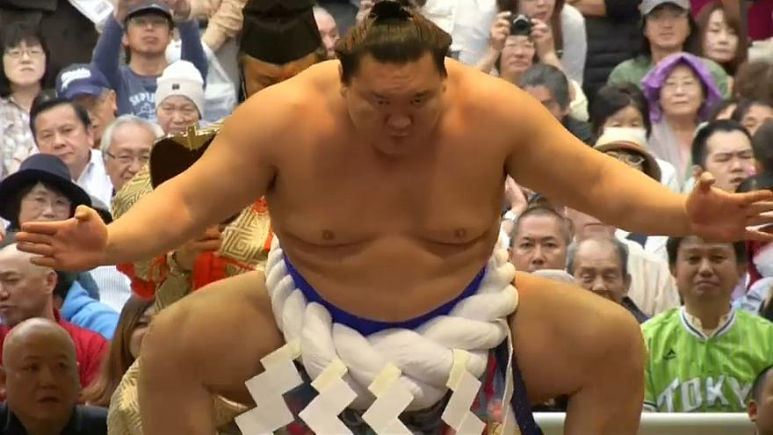

- In 1951 Anime was created by Osamu Tezuka and it was a great success all over the world. Here are some facts about it.
  - 60 percent of the world’s animations are Anime.
  - In Japan more than 40 new animes appear on TV every week.
  - In Japan more paper is used to print picture of anime than is used for toilet paper.
  - All anime is drawn by hand

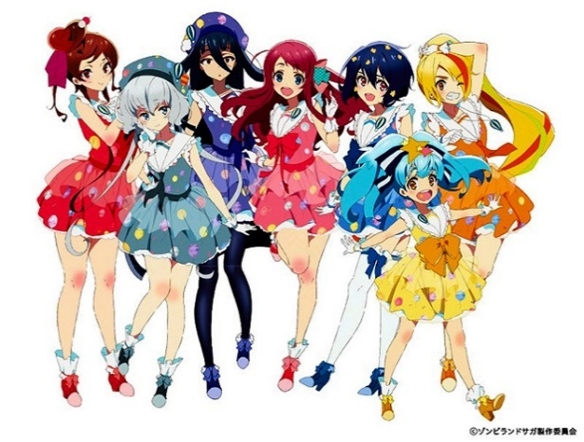

- Japan is most definitely a safe place to go on holidays it has one of the lowest crime rates in the world. The most common crime in Japan is stealing an umbrella.
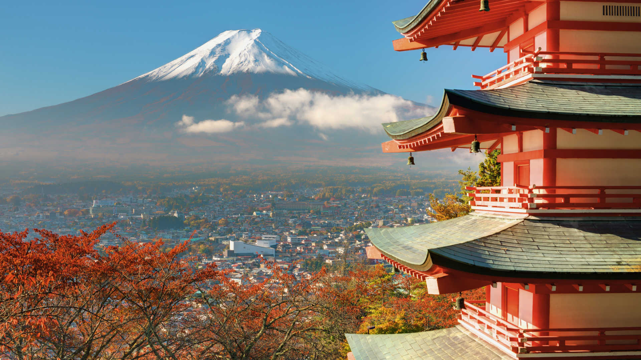

- Japan have the most vending machines in the world. Believe it or not they even have vending machines that give out gold if you put enough money in.

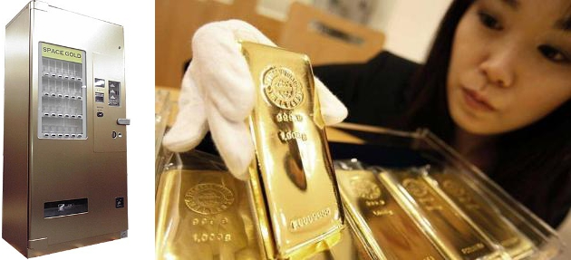

- Japans schools make cleaning an educational subject. They make them clean toilets, classrooms and the school area, but they save loads of money for not getting cleaners.

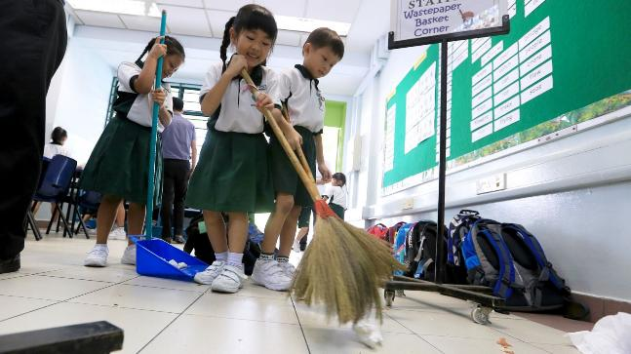

- There is normally over 1500 earthquakes a year! Most of the time they’re small but there are at least 1 or 2 big earthquakes a year.

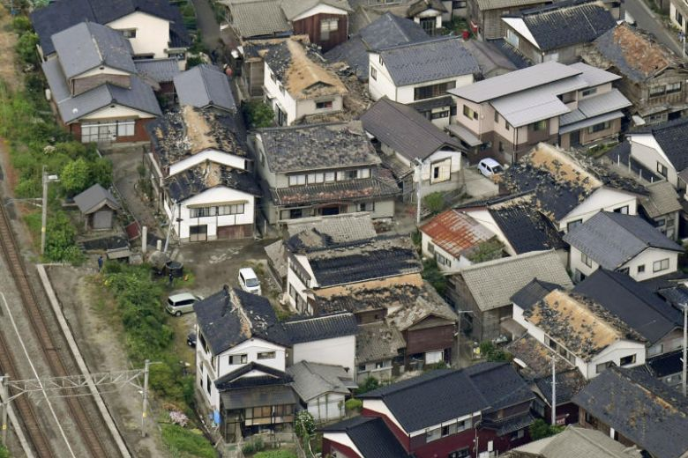
- Apparently fruit is one of the best gifts you can give in Japan. In ancient times fruit used to be very expensive because not many fruits grow in Japan, but now fruit is not as expensive any more.

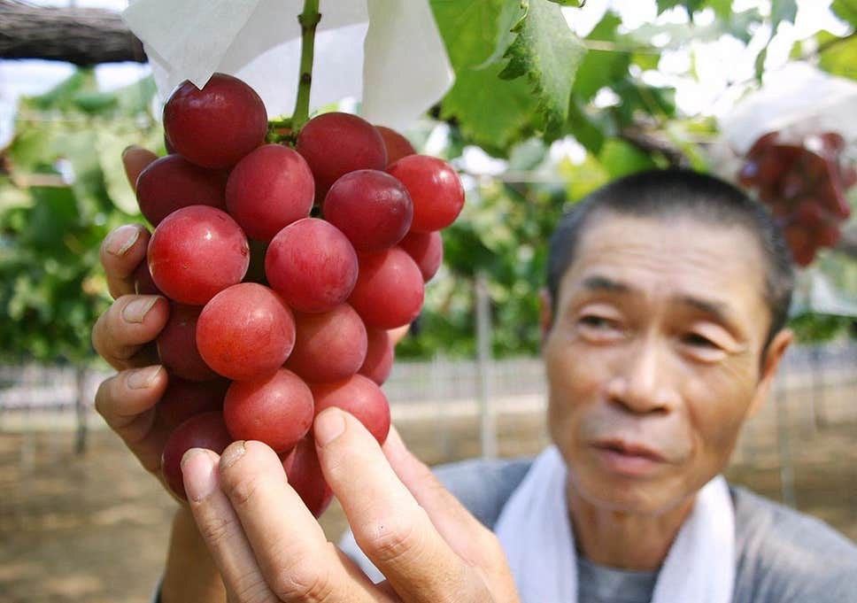

- Slurping is polite. If you go to Japan make sure to go to a noodle place and don’t forget to slurp because it shows the cook that you appreciate the food and it actually enhances the flavour of the food.
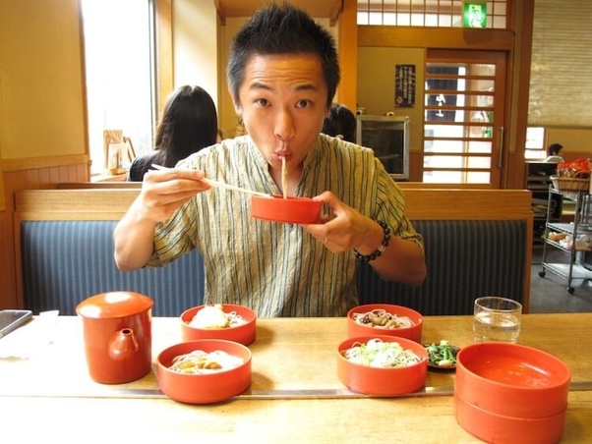

- In Japan you bow instead of shaking hands. Apparently the lower you bow to them the more respect you show to them. Don’t worry if you don’t bow, the Japanese are smart and understand if you don’t know about bowing to them so they will shake hands with you.

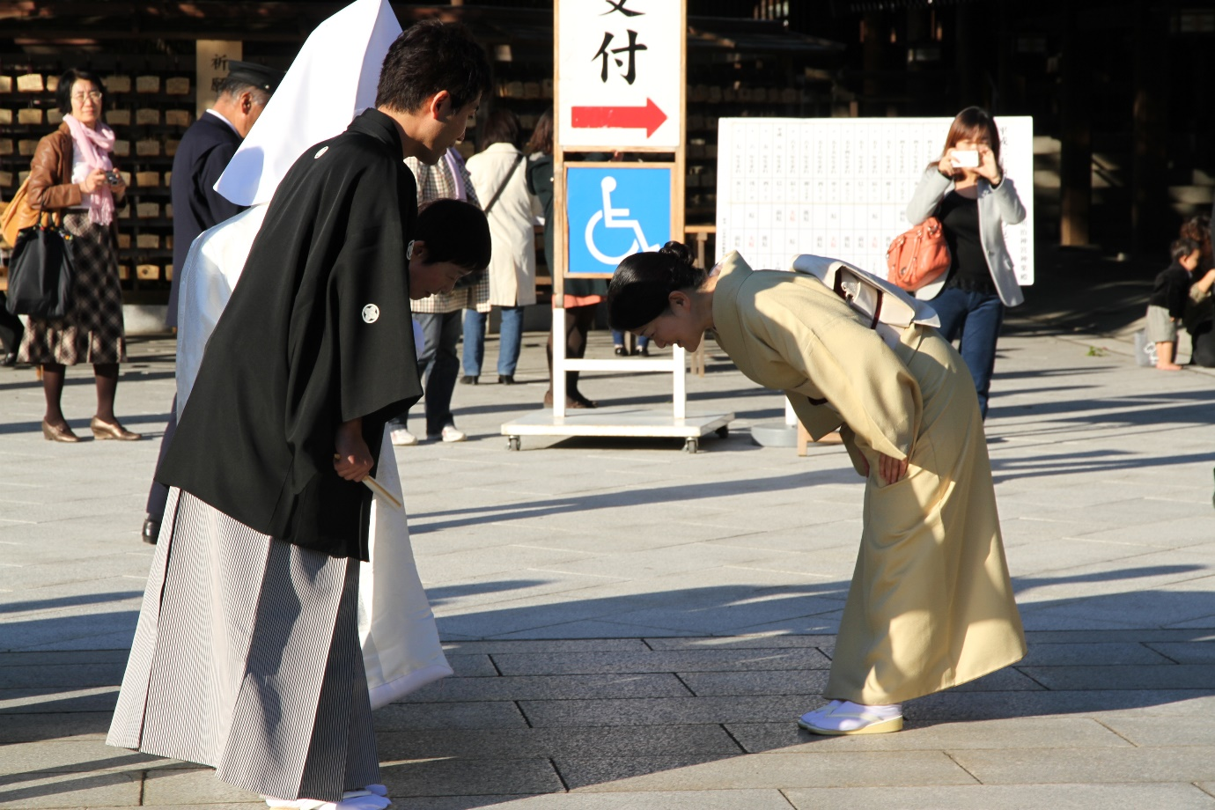

Questions:
1. Who made Anime?
2. What unusual subject is taught in Japanese schools?
3. How many times have Japan hosted the Rugby World Cup?
4. Why do people in Japan slurp when eating food?
5. What’s the most common crime in Japan?

