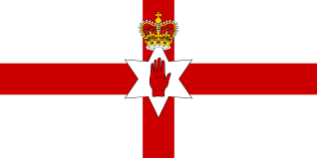

NORTHERN IRELAND FOOTBALL TEAM

Nickname(s) | Green and White Army, Norn Iron
Association | Irish Football Association
Confederation | UEFA (Europe)
Head coach | Michael O'Neill
Captain | Steven Davis
Most caps | Pat Jennings (119)
Top scorer | David Healy (36)
Home stadium | Windsor Park
FIFA code | NIR

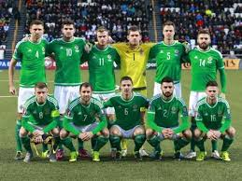

Matches

12 June 2016 Group C
POLAND1-0 NORTHERN IRELAND

16 June 2016 Group C
UKRAINE 17:00 NORTHERN IRELAND

21 June 2016 Group stage
NORTHERN IRELAND 17:00 GERMANY

Group C
 | P | W | D | L | Pts
GERMANY | 1 | 1 | 0 | 0 | 3
POLAND | 1 | 1 | 0 | 0 | 3
NORTHERN IRELAND | 1 | 0 | 0 | 1 | 0
UKRAINE | 1 | 0 | 0 | 1 | 0

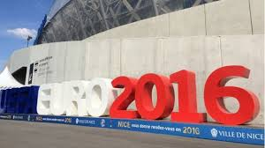

Northern Ireland qualified for their first ever European Championship, Euro 2016 in France after beating Greece 3–1 at Windsor Park on 8 October 2015.

Stadium
Windsor Park
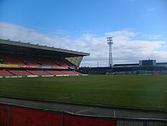l
Northern Ireland play their home matches at Windsor Park, Belfast, home of Linfield F.C., which they have use of on a 108-year lease, giving the owners 15% of revenue, including gate receipts and TV rights.

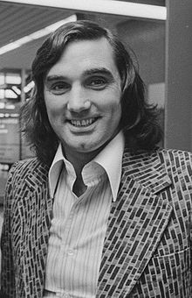
George Best won 37 caps and scored 9 goals for Northern Ireland

