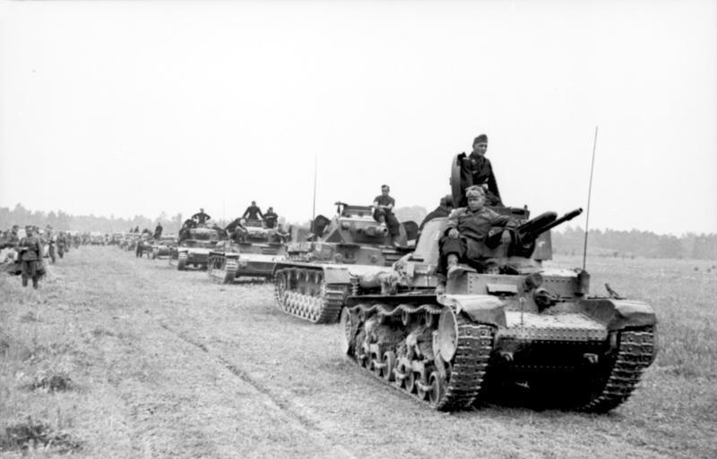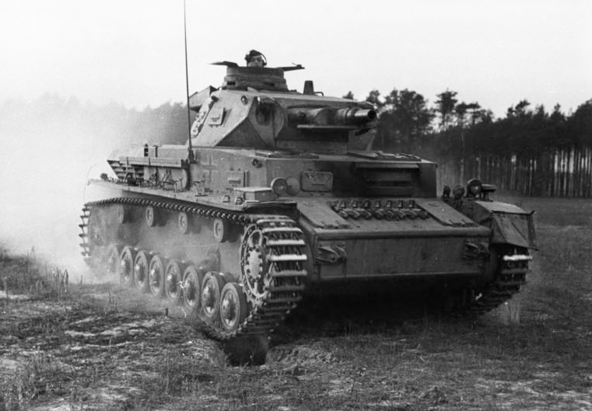
The Magic Bunker

I will put in the bunker
The luftwaffe
That failed to prevail
The RAF in 1941

I will put in the bunker
The Soviet union who were pushed back
to Moscow but mercilessly fought back the German panzers and soldiers

I will put in the bunker
The Imperial Japanese navy aircraft carriers that were sunk by the Airforce and Navy of the United States

I will put in the bunker
The Australian soldiers that held out on the coast of Africa without any support for 2 weeks

My bunker
Is made out of the strongest stone and concrete with the armour of a naval battleship

I shall ride on my bunker
On the battlefront of the Soviets vs the Germans then shall arrive on a British airfield

