Quieter than

Quieter than a sleeping mouse,
Quieter than a library,
Quieter than an abandoned house
Or the hopping of a tiny flea.
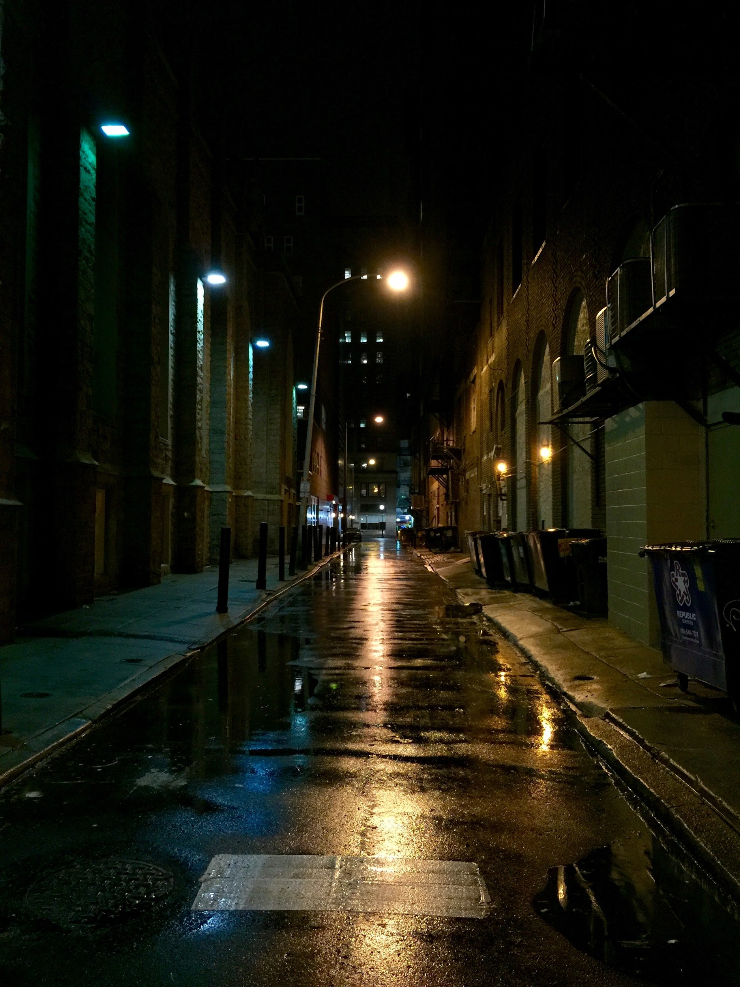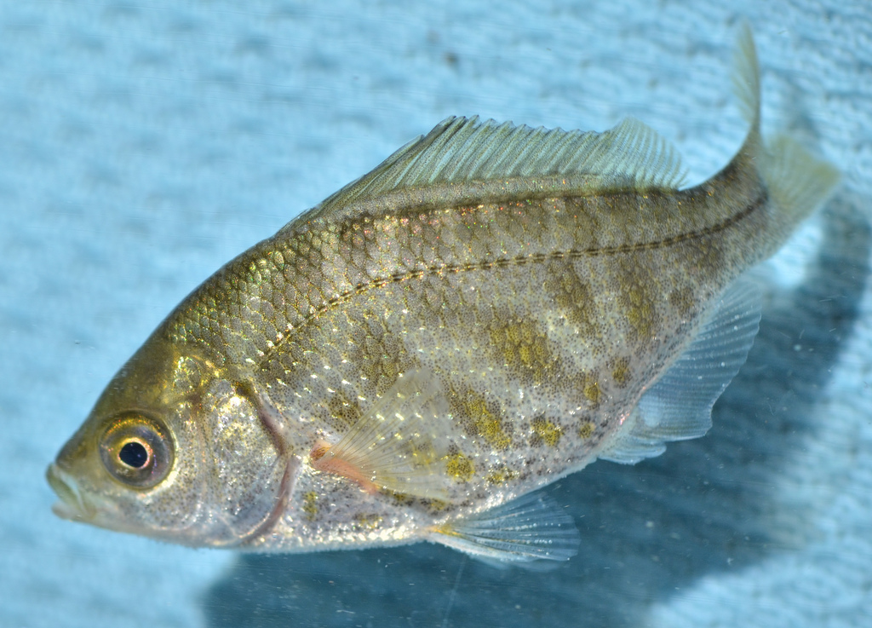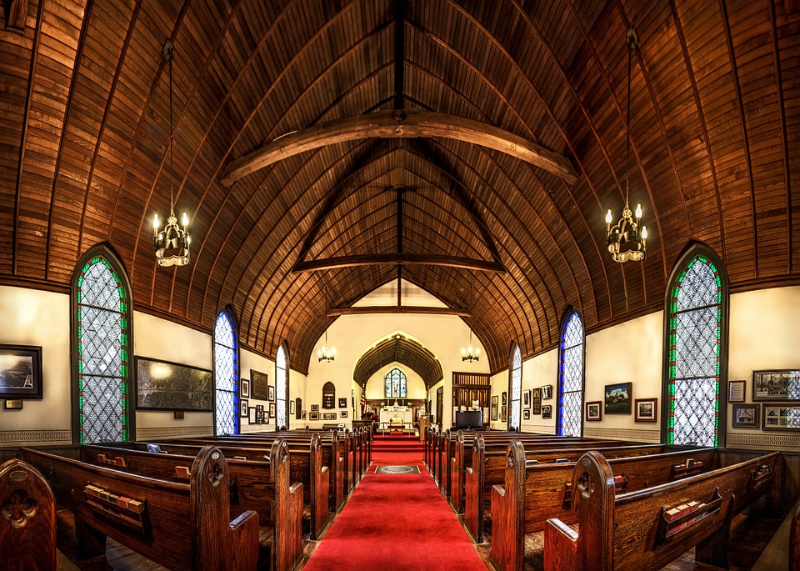
Quieter than a praying church,
quieter than a street by midnight,
Quieter than a swimming perch Or quieter than the ghosts by daylight
By Conor Casey.

