Quieter than…

Quieter than a sleeping mouse,
Quieter than a lib-rar-y,
Quieter than an abandoned house,
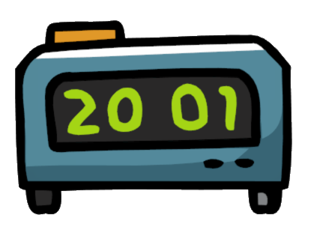
Or the hopping of a tiny flea.

Quieter than an idle guitar,
Quieter than a turning lock,
Quieter than an old old car,
Or the changing of a digital clock.

By Seán corduff

