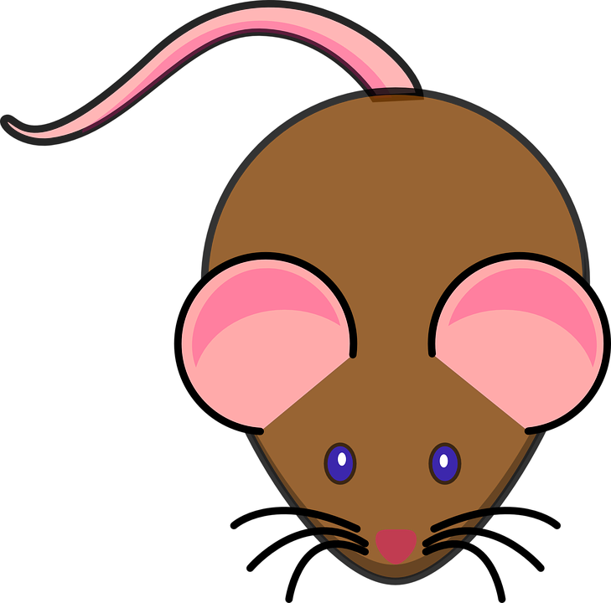
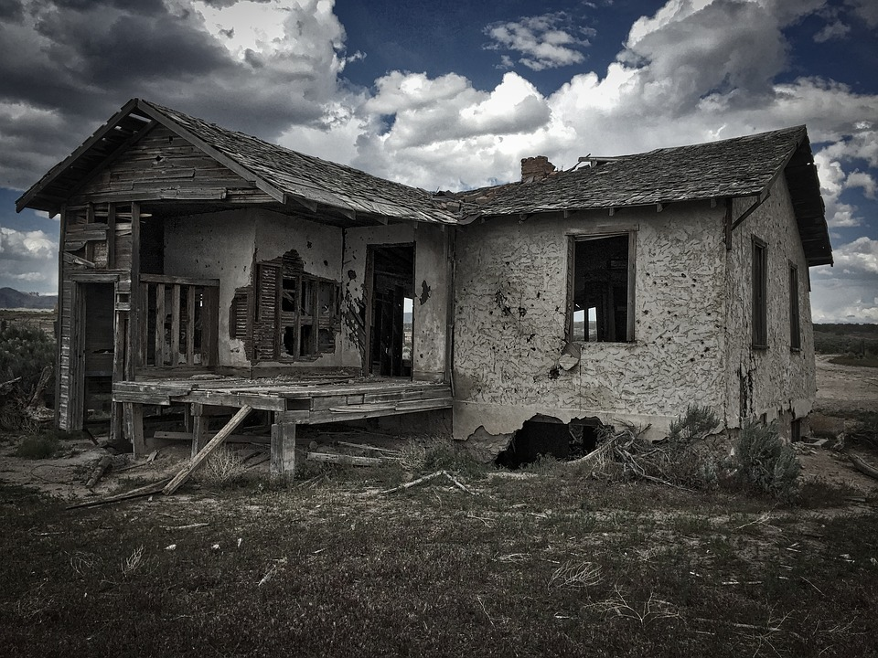
QUIETER THAN A SLEEPING MOUSE Quieter than a library Quieter than an abandoned house
Or a little hopping flea
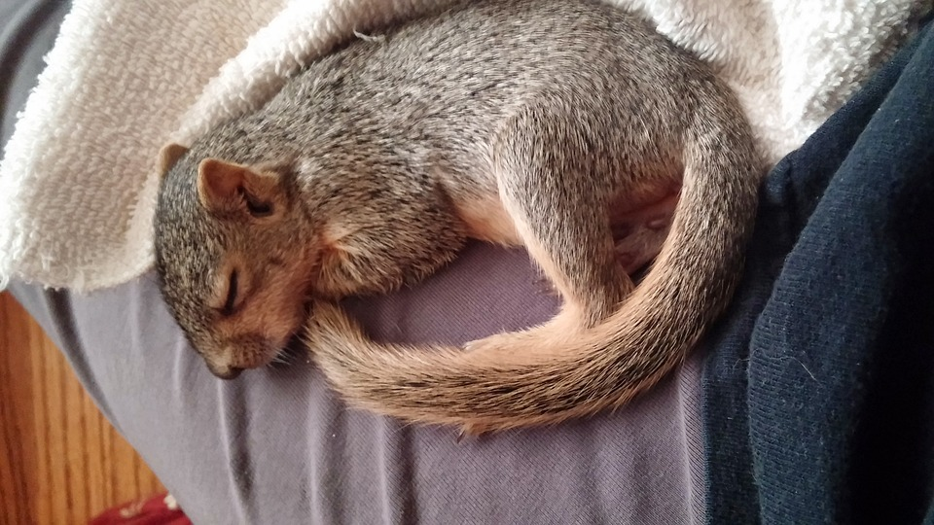
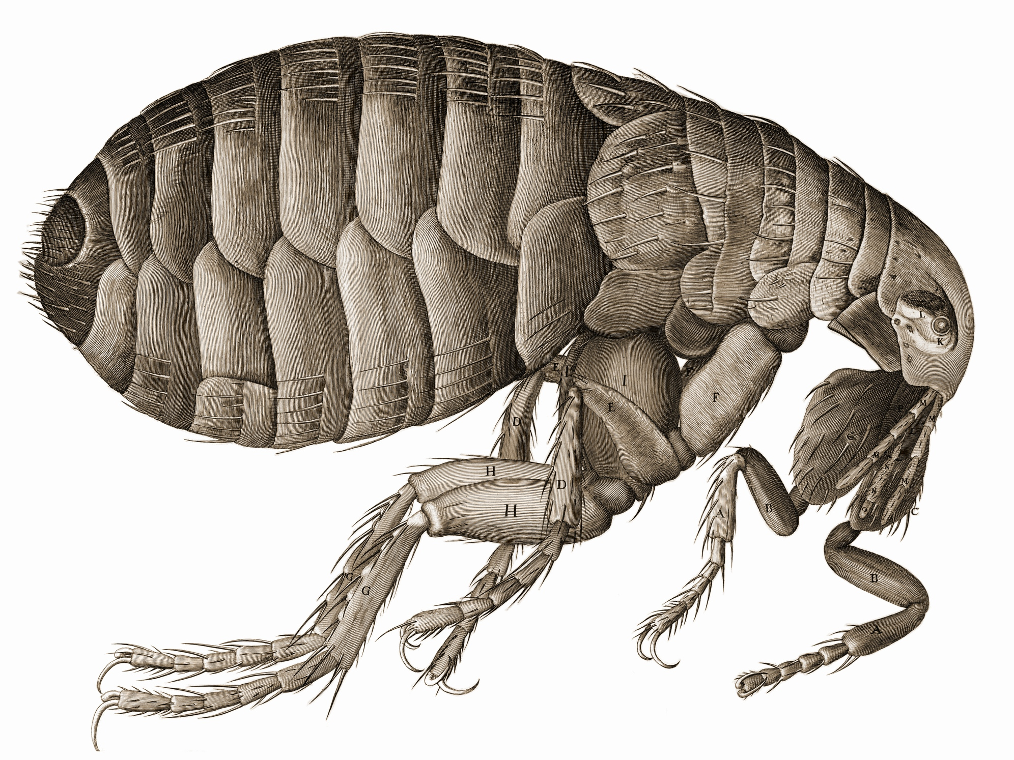
Quieter than a squirell as it sleeps
Quieter than a silent hill

Quieter than a hamster weeps
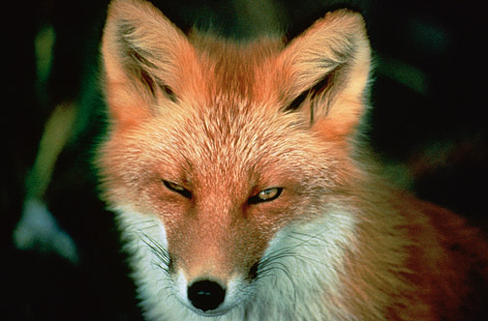
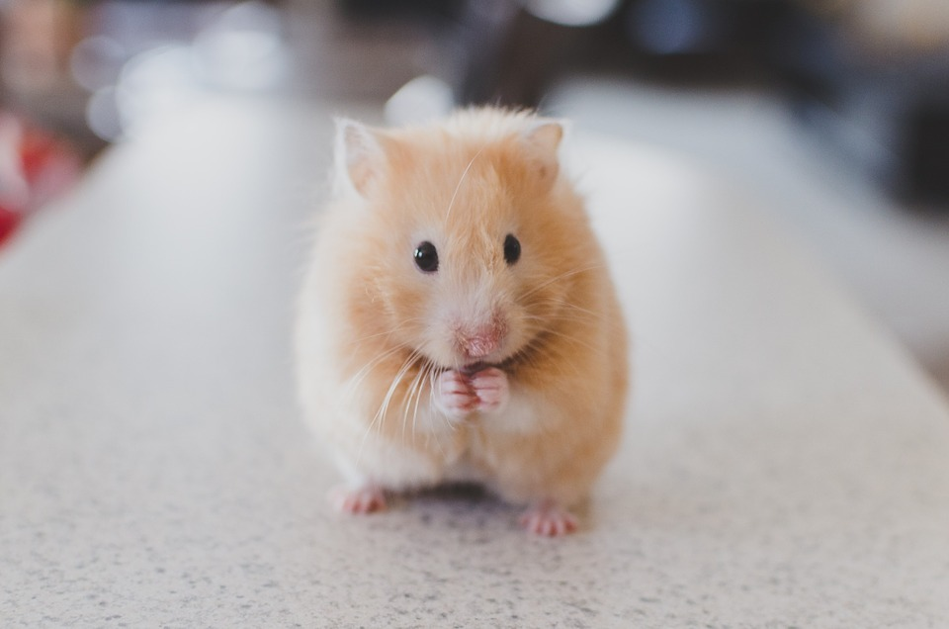
Quieter than a foxes kill
By Ryan leonard

