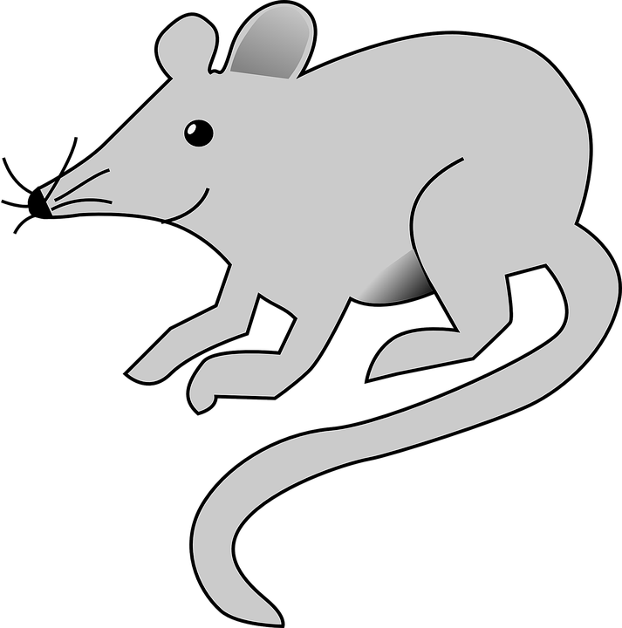
Quieter than

Quieter than a sleeping mouse
Quieter than a library
Quieter than abandoned house
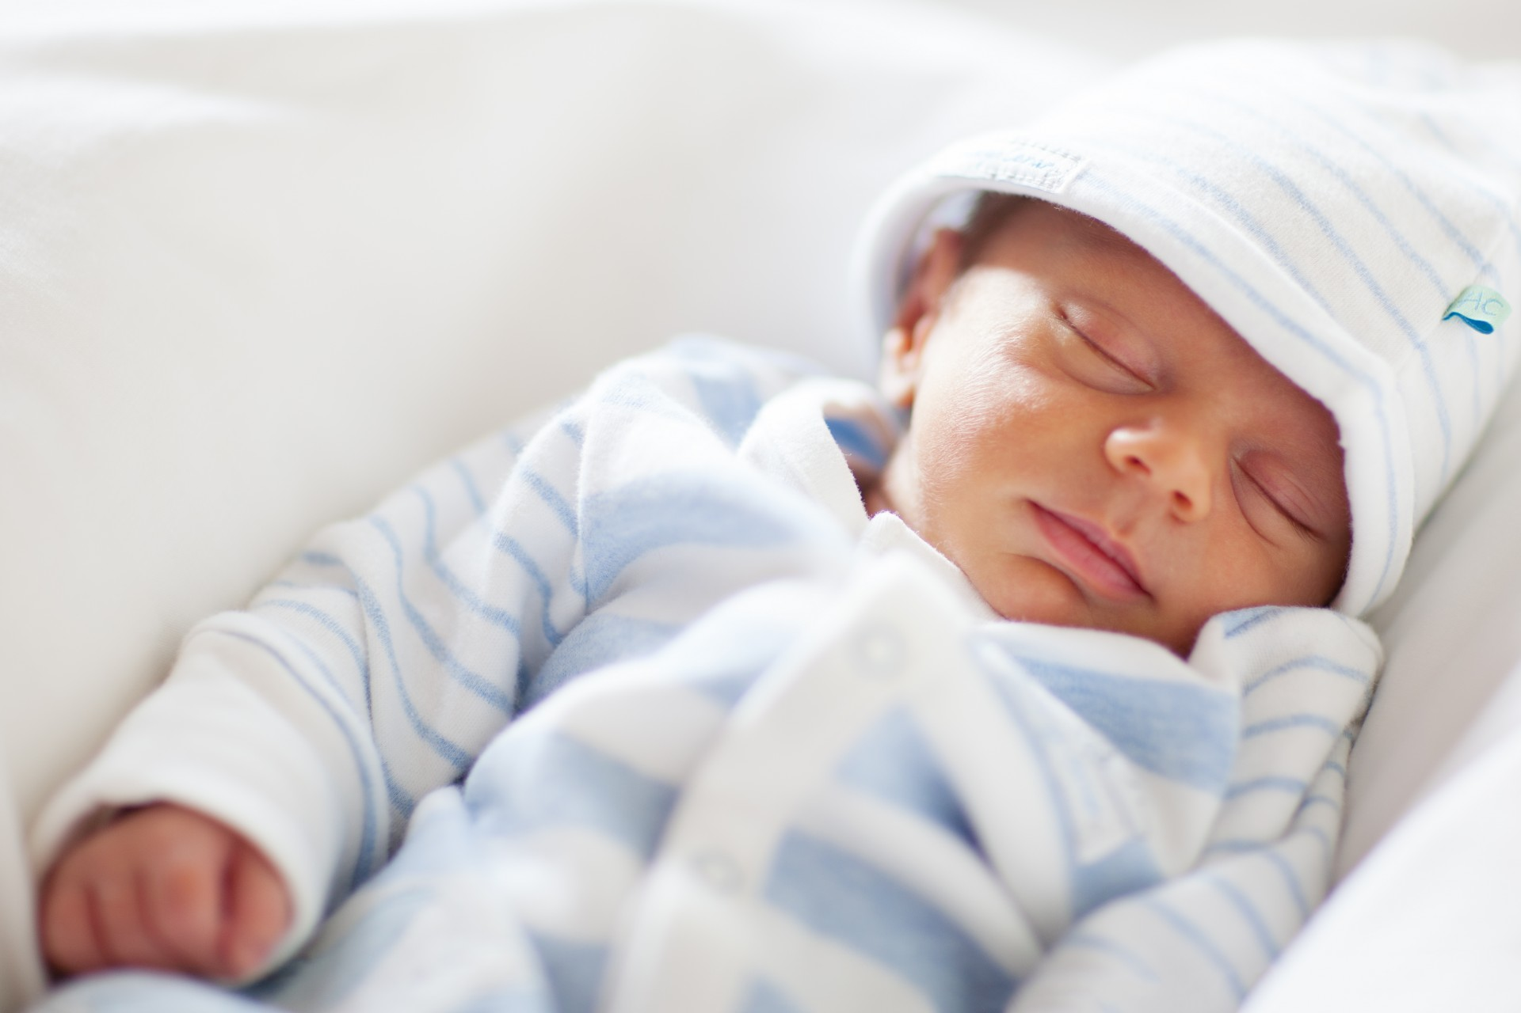
Or the hopping of a tiny flea

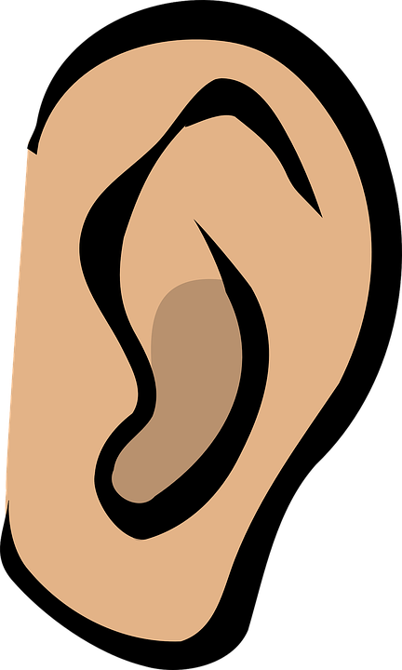
Quieter than the next door sipping tea
Quieter than a baby sleeping
Quieter than the boy whispering to me
Or the happiness of me

By Jason Ilunga

