QUIETER
Than…
Quieter than a sleeping mouse
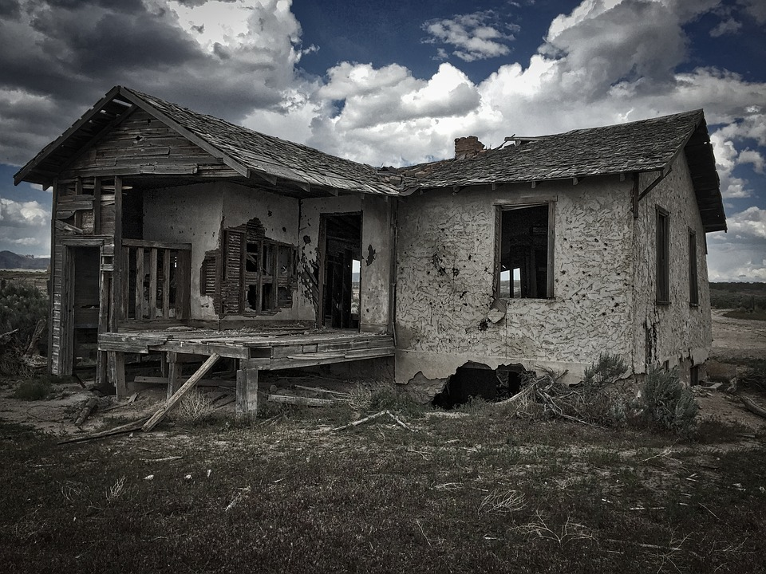
Quieter than a library
Quieter than an abandon house
Quieter than a tiny hopping flea

Quieter than a butterfly
Quieter than someone who is shy
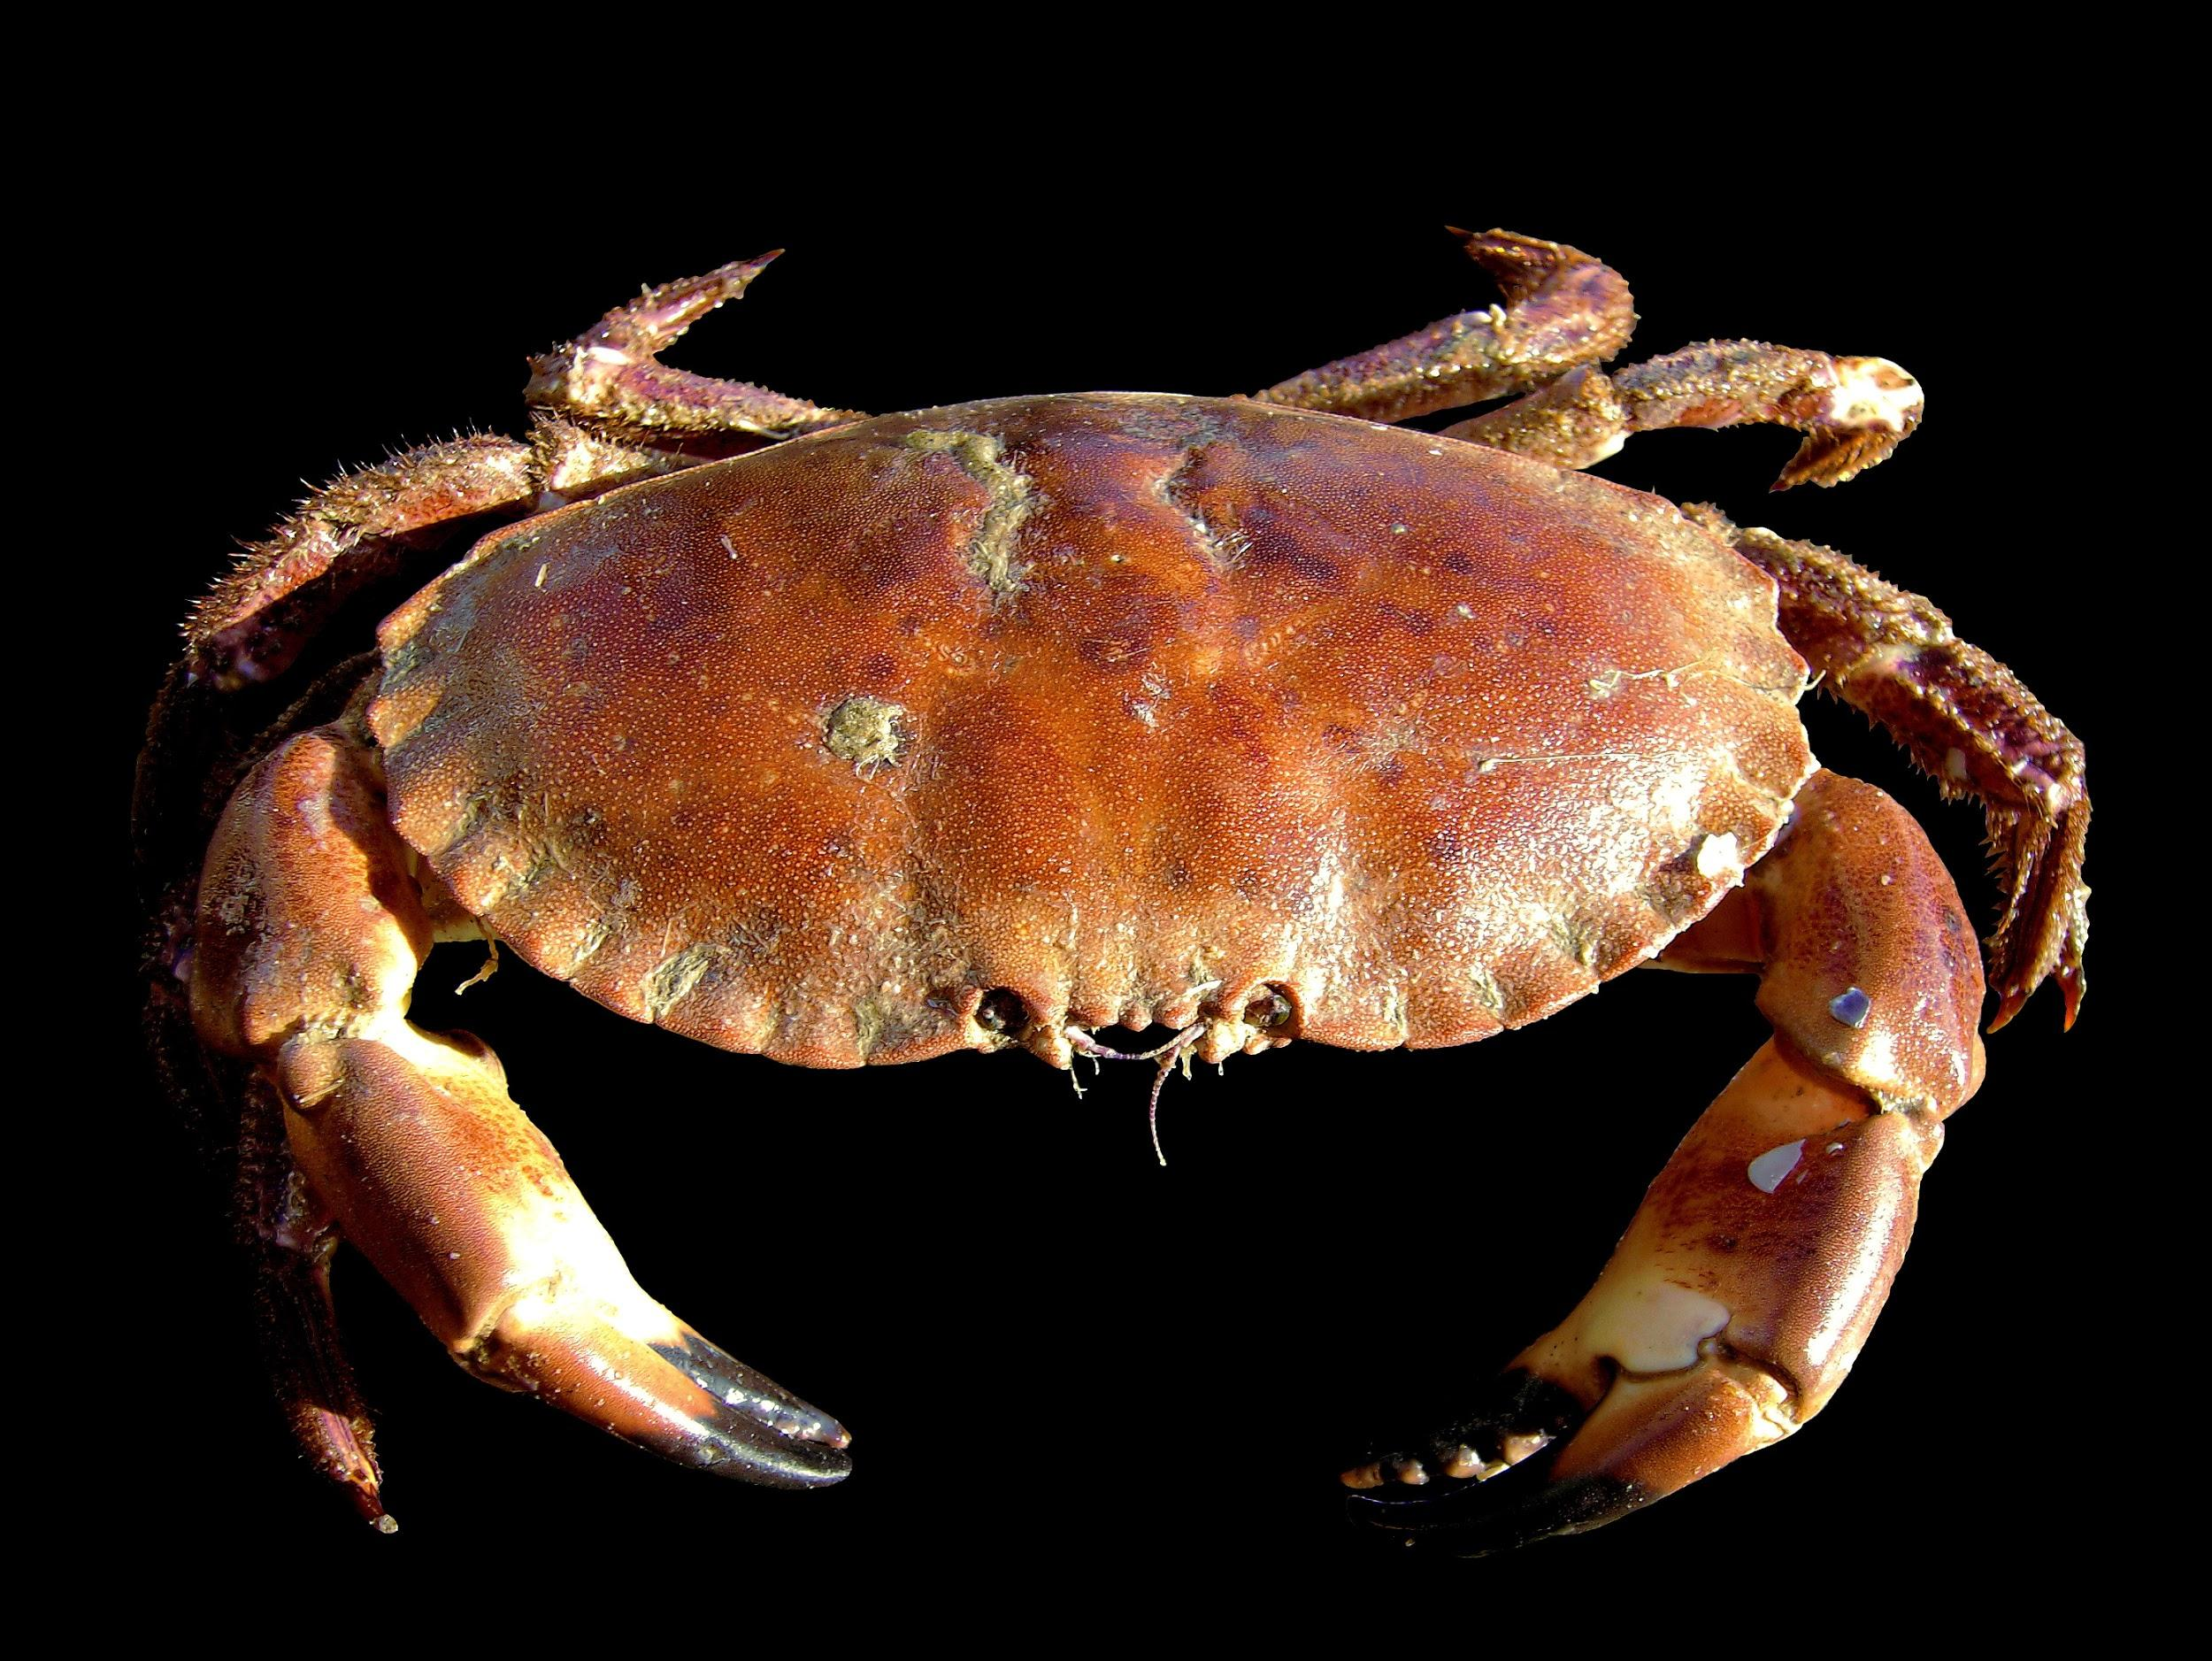
Quieter than a crab
Quieter than a science lab.
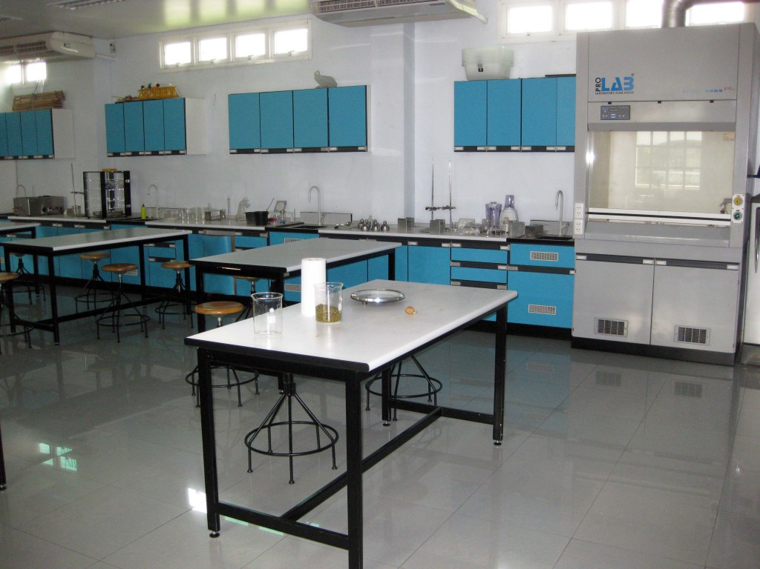

By sean mahoney

