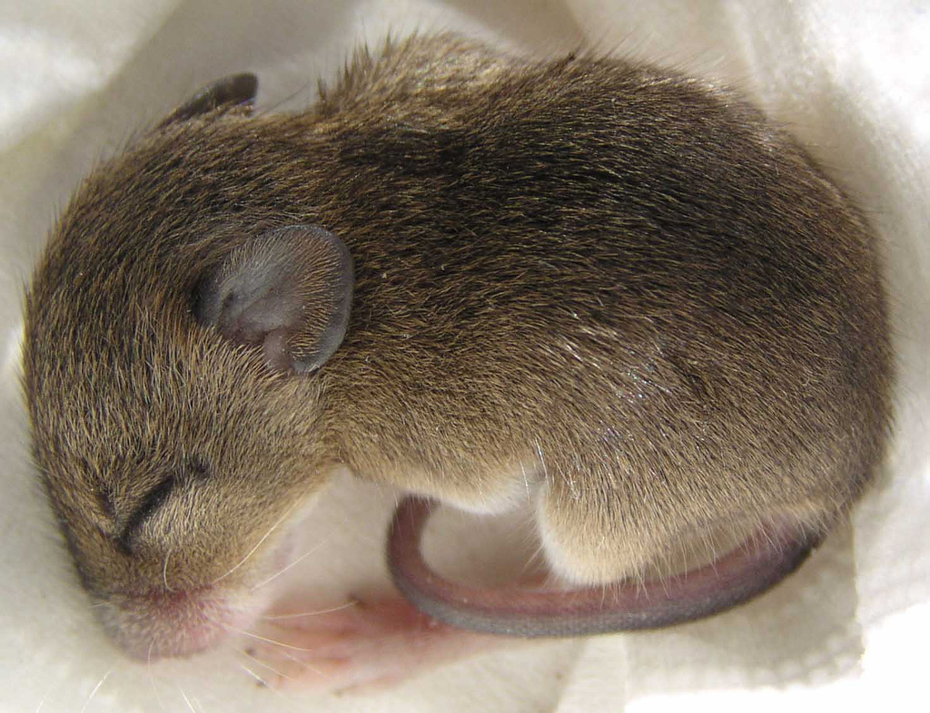
Quieter than a sleeping mouse
Quieter than a library
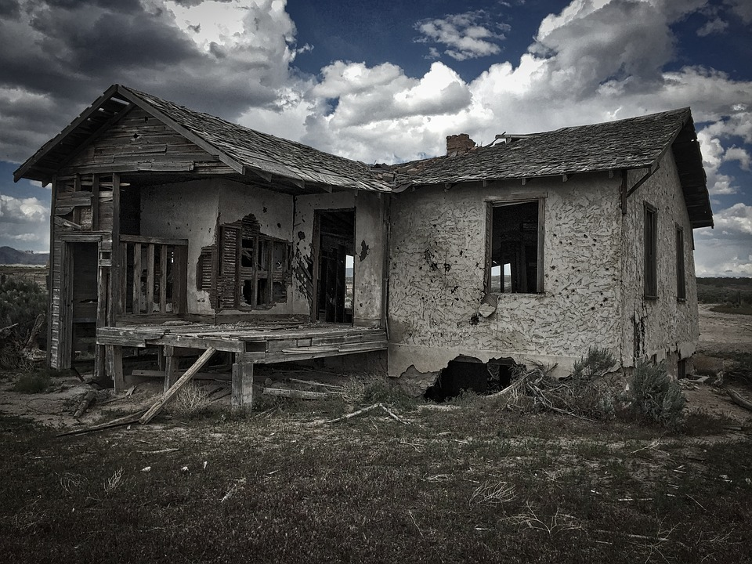
Quieter than an abandoned house
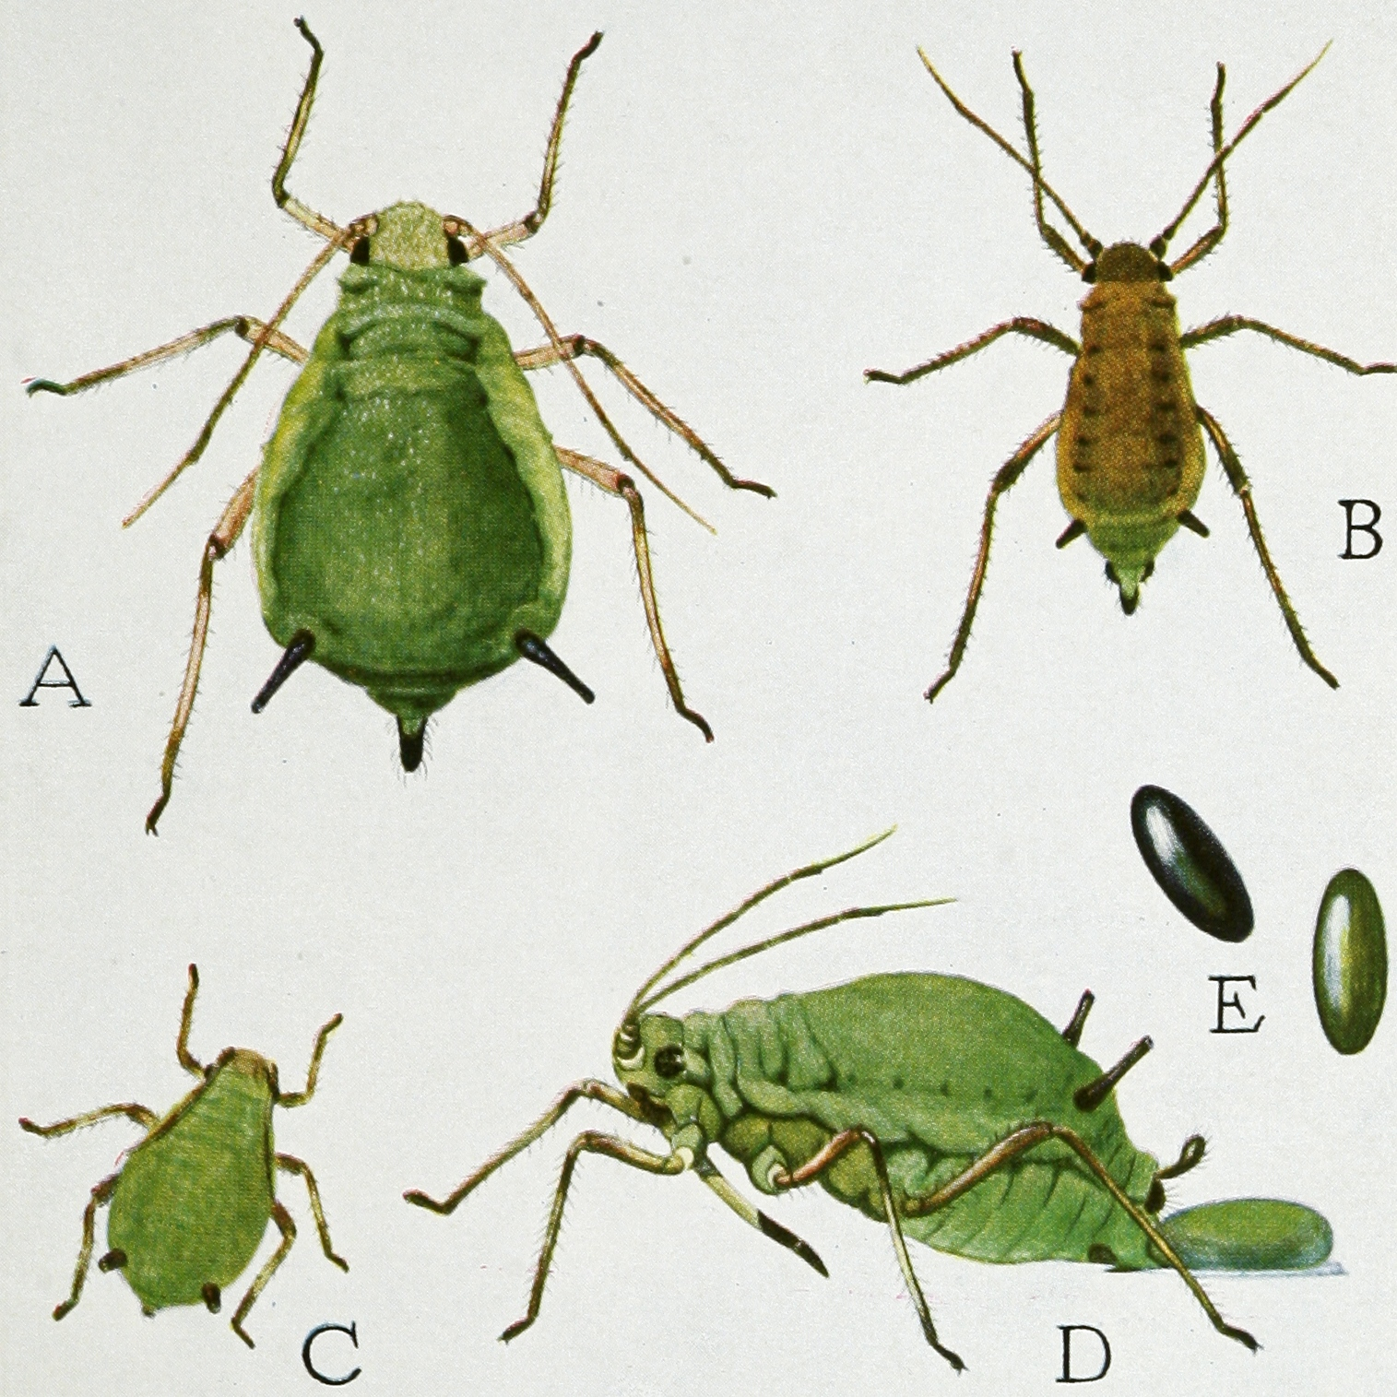
Or a hopping of a flea.

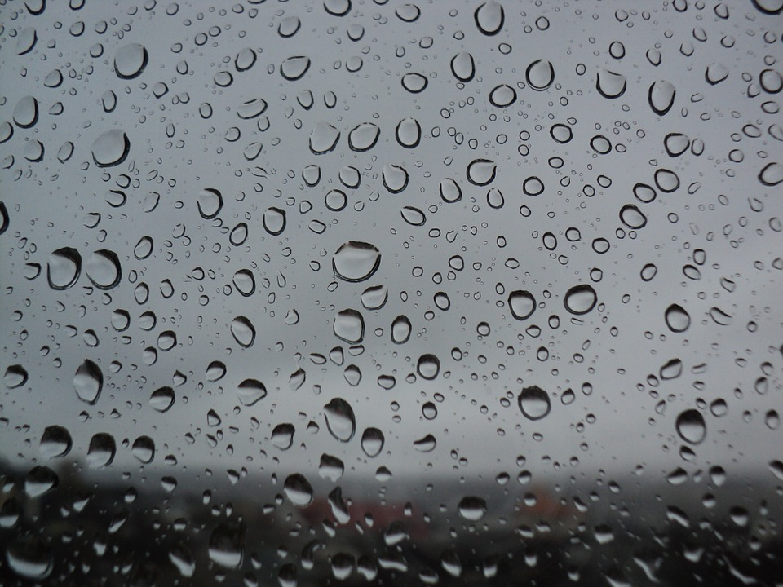
Quieter than a raindrop on a window pane
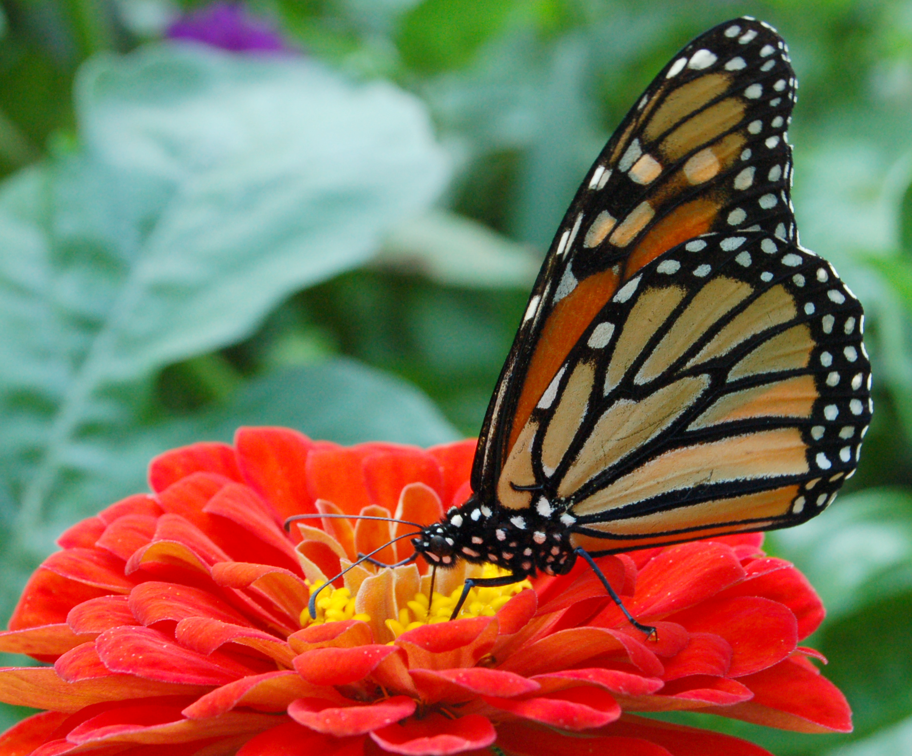
Quieter than a butterfly as it starts to fly away
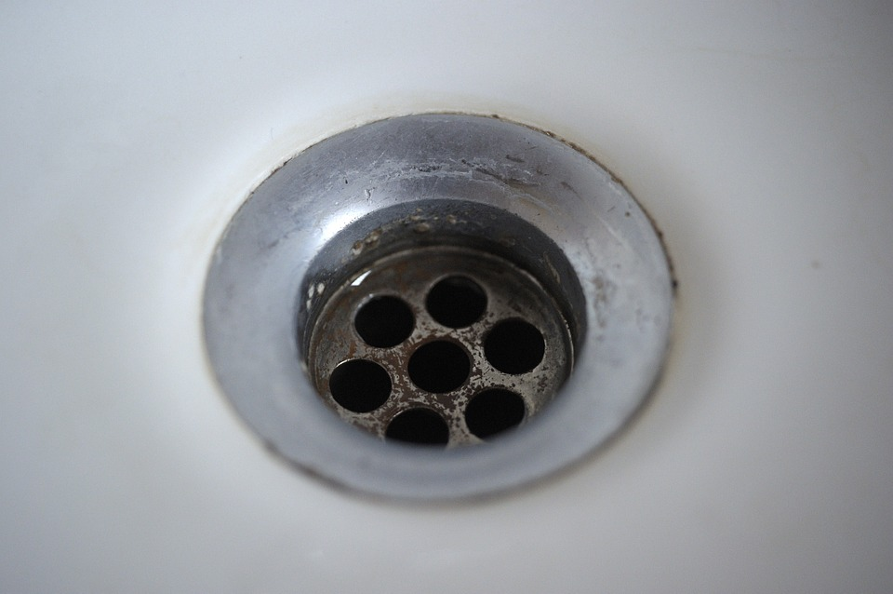
Or quieter than a gurgle of a dirty drain

Quieter than a library at it's quietest stage.
By Kyle Lennox.

