1916 rising

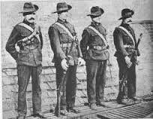
The 1916 rising Ireland vs The British Empire. It was a hard time for Ireland. There were spies from Brittan so Ireland’s great plans didn’t work. they had no chance. Hope you enjoy my project.
There were a lot of important people in the 1916 rising.
Some people in my class are related to them.
Important PEOPLE THAT Helped IN the 1916 RISING
- Padraig PEARse
- JOHN REDMOND
- James Connelly
- John Redmond
- Tom Clarke
5 facts about 1916
- British is trying to build an empire by attacking lots of countries to get world domination

- Lots of innocent people were killed in the cross fire

- If a person died in a war they would send a letter to the closest family member

- Padraig pearse helped a lot in the 1916 and he convinced a lot of people to fight for Ireland

- Ireland showed that even a small country could beat
- Brittan 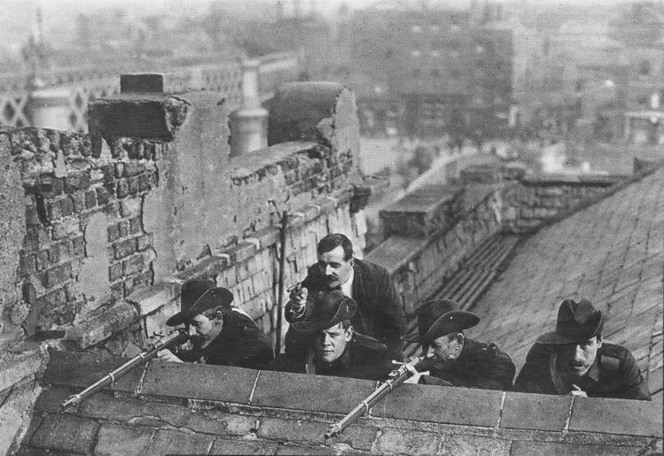

The proclamation
Padraig pearse and 3 others made the proclamation and convinced that Ireland would get independence here is a picture of it below
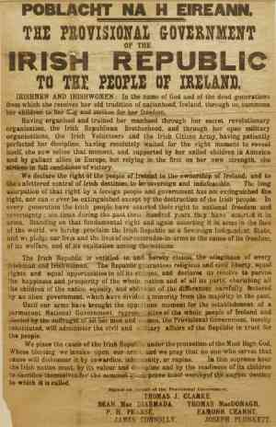
Ireland is a great country and I am happy to live in it 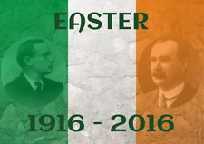 thank u for your time the end

