The Mona Lisa
Nathan Matute
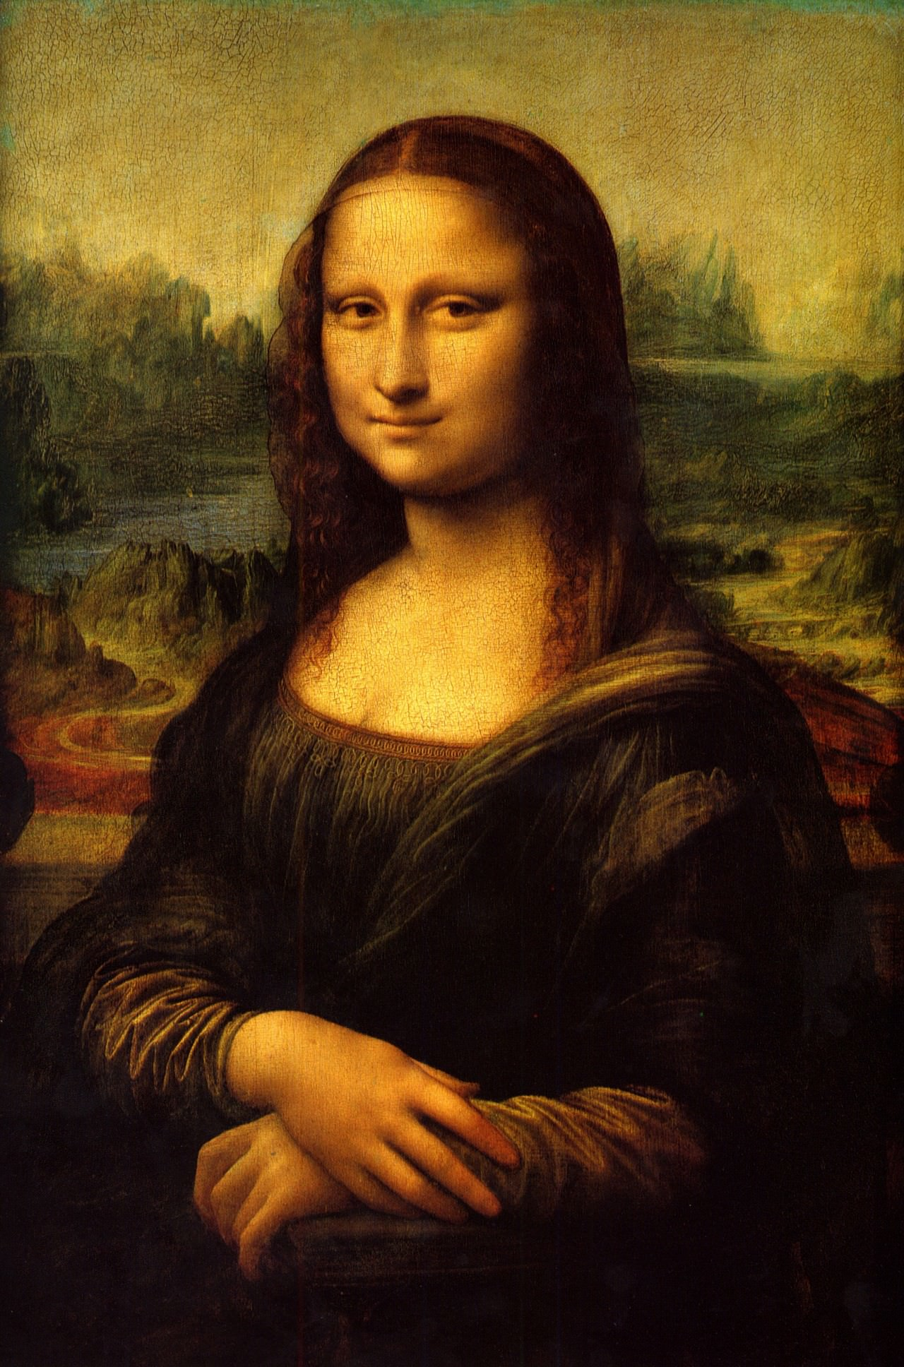
The Mona Lisa was painted by Italian artist Leonardo Da Vinci.

Mona Lisa was placed in Napoleon’s room.

Mona Lisa’s smile has fascinated historians and artist for a very long time. But in 2000 Dr. Margaret Livingstone applied that all it is was your focus and how your mind responds.

In 1956 a man called Ugo Ungaza Villegas threw a rock at the Mona Lisa.

